

**SOFTWARE REQUIREMENT SPECIFICATION (SRS) SIGN-OFF**

**Authorization Memorandum**

This form is to sign-off completion of the Requirement Phase for **CAMPUS MANAGEMENT SOFTWARE AT WORLD SKILL CENTER (WSC).**

World Skill Centre (WSC) acknowledges receipt of the deliverable as part of the Requirement Phase through the submission of this document.

|  |  |
| --- | --- |
| **MODULE NAME** | **Procurement & Inventory Management module** |

| **VERSION HISTORY** | | | |
| --- | --- | --- | --- |
| **Version** | **Author** | **Date** | **Changes** |
|  |  |  |  |
|  |  |  |  |

**WSC AUTHORITY NAME AND**  **SIGNATURE**

**SOUL AUTHORITY NAME AND**  **SIGNATURE**

Pages 1 of 84



**Software Requirement Specification (SRS)**

Of

**Procurement & Inventory Management module**

For Implementation of

**Campus Management Software**

at

**World Skill Center (WSC)**

****

**Sustainable Outreach And Universal**

**Leadership (SOUL) Limited**

**Content**

[A. Abstract 3](#_Toc32516)

[B. Introduction 3](#_Toc13526)

[C. Definition, Acronyms and Abbreviations 3](#_Toc18621)

[D. Overview of the Document 3](#_Toc24481)

[E. Scope of Procurement & Inventory Module 4](#_Toc2841)

[F. WSC Requisition Process Flow 4](#_Toc16502)

[G. WSC Procurement Process Flow 5](#_Toc8326)

[H. List of Screens and their descriptions 5](#_Toc18832)

[1. Quality Inspection 7](#_Toc21935)

[1.1 Quality Inspection Template 7](#_Toc13006)

[1.2 Quality Inspection Parameter 8](#_Toc4462)

[2. Procurement 9](#_Toc25671)

[2.1 Material Request 9](#_Toc28028)

[2.2 Request for Quotation 13](#_Toc8910)

[2.3 Supplier Quotation 17](#_Toc19831)

[2.4 Purchase Order 26](#_Toc30034)

[2.5 Purchase Receipt 42](#_Toc12079)

[2.6 Purchase Invoice 56](#_Toc12922)

[3. Stocks 73](#_Toc1636)

[3.1 Stock Entry 73](#_Toc24562)

[3.2 Stock Setting 80](#_Toc18259)

# Abstract

Software Requirements Specification (SRS) is one of the first phases of system development. This phase results in the Software Requirements Specification (SRS) document, which must contain a complete, concise, high-quality description of the system being considered.

# Introduction

The World Skill Center (WSC) is a premier advanced skill training institute established by the Government of Odisha, Skill Development and Technical Education Department, through the Odisha Skill Development Authority (OSDA). The WSC will impart advanced skill training in eight trades from engineering and service sectors. WSC caters primarily to induct the best talent from ITIs and Polytechnics and train them to become globally employable in emerging areas such as "Industry 4.0". WSC is housed in a state-of-the-art, 18-storey, air-conditioned building with nearly half a million square feet of space in the heart of capital city of Bhubaneswar.

With the Implementation of campus management software for WSC the goal is to streamline the operations and functions of the campus by integrating various processes, such as admissions, course registration, academic progress tracking, and financial management, HRMS, Procurement and Inventory management, etc into a unified system. The implementation also aims at providing a user-friendly interface for all stakeholders, making it easier for them to access the necessary information and complete their tasks with ease. The modules to be covered during the implementation of the software includes:

|  |  |
| --- | --- |
| Students Management Modules | Infrastructure Management |
| Academic System | Finance and Accounting System |
| Procurement & Inventory Management | Training and Placement |
| Human Resources Management System | Application Integration |

# Definition, Acronyms and Abbreviations

The following table explains the terms and abbreviations used in the document:

|  |  |
| --- | --- |
| **Abbreviation** | **Description** |
| SRS | Software Requirements Specification |
| SLCM | Student Life Cycle Management |
| R | Rename - When a field is Renamed |
| N | New - When a New field is Added |
| D | Delete - When an Existing field is Deleted |
| NA | Not Applicable |
| RFQ | Request for Quotation |
| PO | Purchase Order |

# Overview of the Document

This requirement document provides a detailed overview of the functional and non-functional requirements of a project. It serves as a communication tool between stakeholders, including developers, project managers, and end-users. The purpose of this requirement document is to define and document the project's objectives, scope, and expectations, and to ensure that all stakeholders have a clear understanding of what the project entails.

This document covers all the functional requirements of the Procurement & Inventory management module, which includes the Buying, Stock and Asset module. The document describes requirements for Items, Suppliers, Warehouses, Material request, Request for quotation, Supplier quotation, Purchase order, Purchase Invoice, Purchase Receipt, Stock Entry, Quality Verification upon receivable of products, several workflows of these processes using different designation in the ERP system.

# Scope of Procurement & Inventory Module

* **Purchase Requisitions**
* **Stores & Inventory Management**
* **Receipt, verification & acceptance of goods**
* **Stock entry**
* **Issue of goods to sections / departments**
* **Invoice entry transfer to accounts/Directorate**
* **Stock Register**
* **Fixed assets Register**
* **Sectional Indent Register**
* **Sectional Stock Register**
* **Scraps / Obsolete Items management**

Following functionalities are covered in this SRS document:

* **Purchase Requisitions**
* **Stores & Inventory Management**
* **Receipt, verification & acceptance of goods**
* **Stock entry**
* **Issue of goods to sections / departments**
* **Invoice entry transfer to accounts/Directorate**
* **Stock Register**
* **Sectional Indent Register**
* **Sectional Stock Register**

# WSC Requisition Process Flow

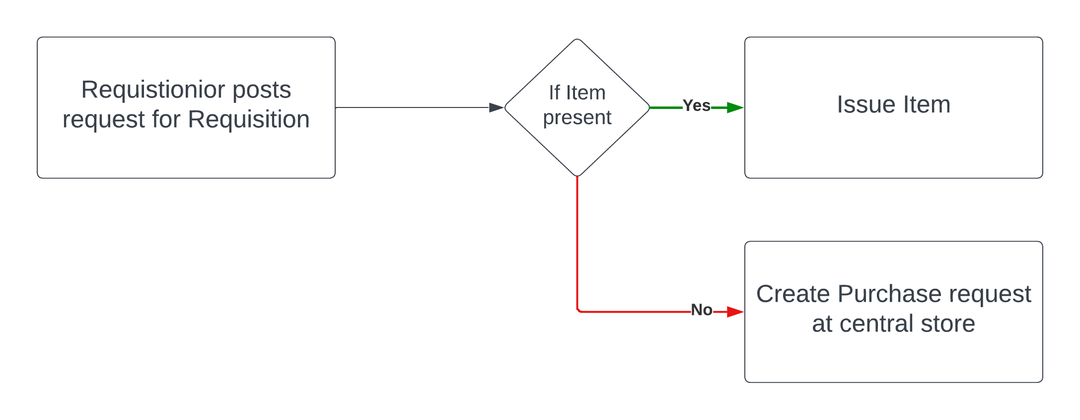

Fig: Requisition process flow diagram

1. The Requisition workflow starts when a department user fills in a material request form.
2. Approval is based on the item that is requested along with the amount of total requisition upon being approved by the necessary authorities.
3. Approval by the Procurement department, where the stock is checked, if present in the central store, it is issued to the requesting department, else Procurement to the vendor is raised.

# WSC Procurement Process Flow

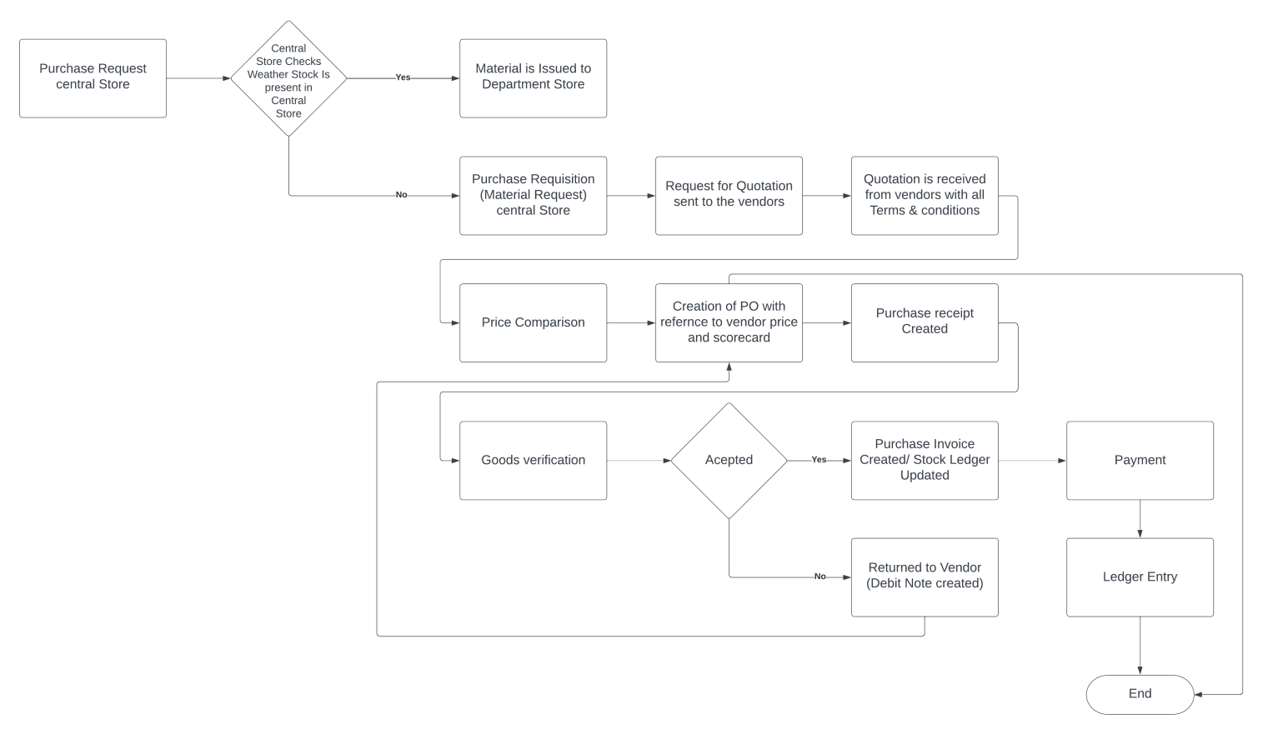

Fig: Procurement process flow diagram

1. If the item requested by the department is not available in the central store, the procurement department raises a material request to buy that item
2. Request for quotation to all suppliers is created
3. For each request for quotation, supplier's price is raised and then L1 quotation is picked
4. A PO is created for L1 suppliers mentioning all terms and conditions, discounts, taxes, etc..
5. Following this, for each batch of items received , purchase receipt will be created
6. After stock verification, the stock will either be accepted or be returned, If returned, debit note is created
7. After full items are received as per PO, Purchase Invoice is created, which is followed by payment and creating Ledger entry for the transaction against the supplier

# List of Screens and their descriptions

|  |  |  |
| --- | --- | --- |
| **Sl no** | **Existing Application** Screen Name | **Description** |
| 1 | [Quality Inspection Template](" \l "_Toc21363 ) | You can add inspection parameters and acceptance criteria in the template, which can be easily fetched into any Quality Inspection. |
| 2 | [Quality Inspection Parameter](" \l "_Toc30773 ) | A single Quality Inspection consists of many Quality Checks (Parameters) within it. Each of these checks could be Numeric, Non-numeric or Formula Based. |
| 3 | [Material Request](" \l "_Toc16439 ) | A Material Request is a simple document identifying a requirement of a set of Items (products or services) for a particular reason. |
| 4 | [Request for Quotation](" \l "_Toc13488 ) | A Request for Quotation is a document that an organization sends to one or more suppliers asking a quotation for items. |
| 5 | [Supplier Quotation](" \l "_Toc17467 ) | A Supplier Quotation is document by a potential supplier specifying the cost of goods or services they'll provide within a specified period. |
| 6 | [Purchase Order](" \l "_Toc11241 ) | A Purchase Order is a binding contract with your Supplier that you promise to buy a set of items under given conditions |
| 7 | [Purchase Receipt](" \l "_Toc23137 ) | A Purchase Receipts are made when you accept Items from your Supplier usually against a Purchase Order |
| 8 | [Purchase Invoice](" \l "_Toc25890 ) | A Purchase Invoice is a bill you receive from your Suppliers against which you need to make the payment |
| 9 | [Stock Entry](" \l "_Toc28242 ) | A Stock Entry lets you record Item movement between Warehouses |
| 10 | [Stock Setting](" \l "_Toc21148 ) | You can set default settings for your stock related transactions from the Stock Settings page |

## Quality Inspection

### 1.1 Quality Inspection Template

**General Description**

The Following table describe overall information about this screen:

|  |  |
| --- | --- |
| **Description :** | 1. User can mark your incoming or outgoing products for Quality Inspection. |
| **Navigation :** | Home > Material Management > Quality Inspection > Quality Inspection template |
| **Pre-requisites :** | 1. Quality Inspection Parameter |

**Quality Inspection Template Screenshot**

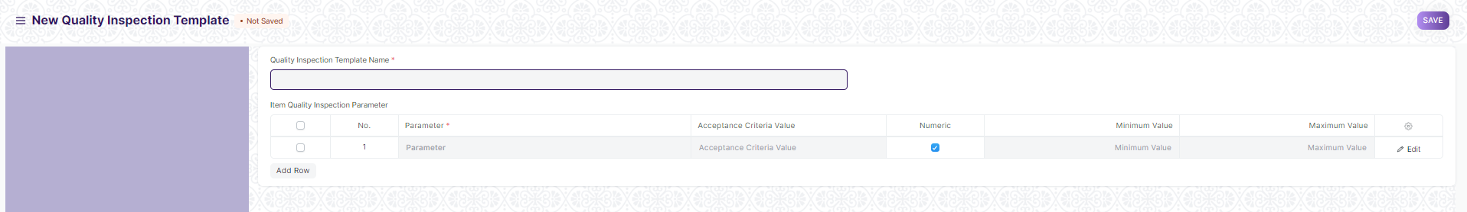

Fig: Quality Inspection Template

**UI Fields**

The “Quality Inspection Template” screen shall consist of the following fields:

|  |  |  |  |  |  |
| --- | --- | --- | --- | --- | --- |
| **Field Label** | **Field Type** | **Validation/Action** | **Mandatory** | **Remarks** | **R/N/D** |
| Quality Inspection Template Name | Text Field | User will give input | Yes |  |  |
| **Item Quality Inspection Parameter** | **Table** |  |  | This table is describe below |  |
| **Item Quality Inspection Parameter (Child Table)** | | | | | |
| **Field Label** | **Field Type** | **Validation/Action** | **Mandatory** | **Remarks** | **R/N/D** |
| Parameter | Link | Value will fetched from Quality Inspection Parameter and user will select any one. | Yes |  |  |
| Parameter Group | Link | This field will visible when Parameter data selected and value will fetched from Quality Inspection Parameter Group and user will select any one. |  |  |  |
| Acceptance Criteria Value | Text Field | If Numeric and Formula Based Criteria Un-Checked then this filed will be visible and user will give input |  |  |  |
| Numeric | Checkbox | If checked then Minimum value and Maximum Value field visible. |  |  |  |
| Minimum Value | Number | User will give input |  |  |  |
| Maximum Value | Number | User will give input |  |  |  |
| Formula Based Criteria | Checkbox | If checked then Acceptance Criteria Formula field will visible |  |  |  |
| Acceptance Criteria Formula | Code | User will give input,This are useful for more complex scenarios where just specifying a range or an acceptance value is not enough. |  |  |  |

**Users: Roles and Permissions**

The following table describes the users and their roles and permissions for the screens :

|  |  |  |  |  |  |  |  |  |  |
| --- | --- | --- | --- | --- | --- | --- | --- | --- | --- |
| **ID** | **Role** | **Select** | **Read** | **Write** | **Create** | **Delete** | **Submit** | **Cancel** | **Amend** |
|  | GM-Procurement & Contract Management | Yes | Yes | Yes | Yes | Yes | NA | NA | NA |
|  | Purchase Manager | Yes | Yes | Yes | Yes | Yes | NA | NA | NA |

### 1.2 Quality Inspection Parameter

**General Description**

The Following table describe overall information about this screen:

|  |  |
| --- | --- |
| **Description :** | 1. Quality Inspection Parameter is master Screen for Quality Inspection Template. |
| **Navigation :** | Home > Material Management > Quality Inspection > Quality Inspection Parameter |
| **Pre-requisites :** | NA |

**Quality Inspection Parameter Screenshot**

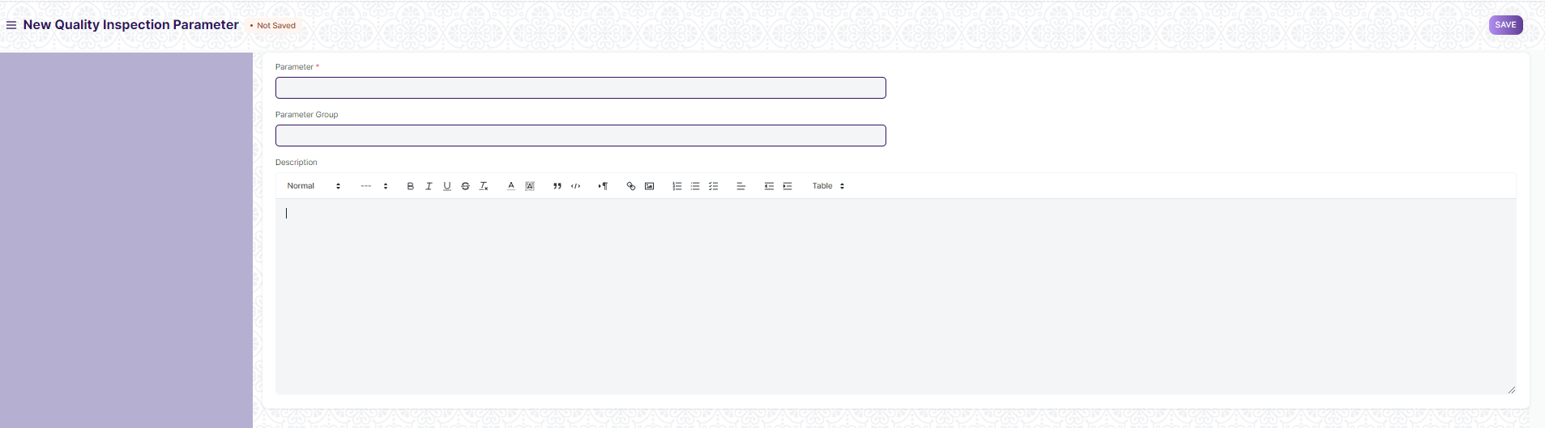

Fig: Quality Inspection Parameter

**UI Fields**

The “Quality Inspection Parameter” screen shall consist of the following fields:

|  |  |  |  |  |  |
| --- | --- | --- | --- | --- | --- |
| **Field Label** | **Field Type** | **Validation/Action** | **Mandatory** | **Remarks** | **R/N/D** |
| Parameter | Text Field | User will give input | Yes |  |  |
| Parameter Group | Link | Value will fetched from Quality Inspection Parameter Group and user will select any one |  |  |  |
| Description | Text Editor | User will give input |  |  |  |

**Users: Roles and Permissions**

The following table describes the users and their roles and permissions for the screens :

|  |  |  |  |  |  |  |  |  |  |
| --- | --- | --- | --- | --- | --- | --- | --- | --- | --- |
| **ID** | **Role** | **Select** | **Read** | **Write** | **Create** | **Delete** | **Submit** | **Cancel** | **Amend** |
|  | GM-Procurement & Contract Management | Yes | Yes | Yes | Yes | Yes | NA | NA | NA |
|  | Purchase Manager | Yes | Yes | Yes | Yes | Yes | NA | NA | NA |

## Procurement

### 2.1 Material Request

**General Description**

The Following table describe overall information about this screen:

|  |  |
| --- | --- |
| **Description :** | 1. **A Material Request is a simple document identifying a requirement of a set of Items (products or services) for a particular reason.** |
| **Navigation :** | Home > Material Management > Buying > Material Request |
| **Pre-requisites :** | 1. Item 2. UOM |

**Material Request Screenshot**

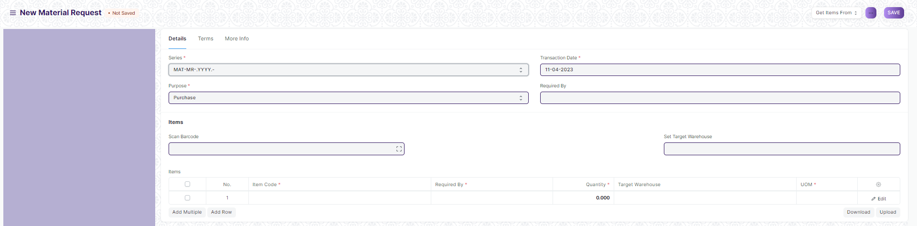

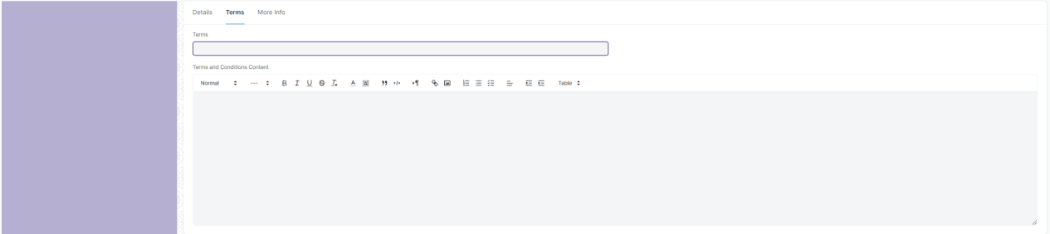



Fig: Material Request

**UI Fields**

The “Material Request” screen shall consist of the following fields:

|  |  |  |  |  |  |
| --- | --- | --- | --- | --- | --- |
| **Field Label** | **Field Type** | **Validation/Action** | **Mandatory** | **Remarks** | **R/N/D** |
| **Details(Tab Break)** | | | | | |
| Series | Dropdown | MAT-MR-.YYYY.-( User will not able to change) |  |  |  |
| Purpose | Dropdown | * Purchase * Material Transfer * Material Issue * Manufacture * Customer Provided   (User can able to select any one) |  |  |  |
| Customer | Link | When select Customer Provider in Purpose Field then this field will be visible and Value will fetched from Customer and user will select any one. |  |  |  |
| Company | Link | Value will fetched from Company and user will select any one |  |  |  |
| Transaction Date | Date Picker | Date fill fetch auto but user can able to change |  |  |  |
| Required By | Date Picker | User will give date |  |  |  |
| Scan Barcode | Text Field | User will give input. By Reader or camera user will also give input |  |  |  |
| Set Source Warehouse | Link | When select Material Transfer in Purpose Field then this field will be visible and Value will fetched from Warehouse and user will select any one. |  |  |  |
| Set Target Warehouse | Link | Value will fetched from Warehouse and user will select any one |  |  |  |
| **Items** | **Table** |  | Yes | This table is describe below |  |
| **Terms(Tab Break)** | | | | | |
| Terms | Link | Value will fetched from “Terms and Conditions” and user will select any one |  |  |  |
| Terms and Conditions Content | Text Editor | User will give Input |  |  |  |
| **More Info(Tab Break)** | | | | | |
| Status | Dropdown(Read Only) | * Draft * Submitted * Stopped * Cancelled * Pending * Partially Ordered   (Data will fetch automatically) |  |  |  |
| % Ordered | Percent | This field will be visible when Purchase will be completed |  |  |  |
| Transfer Status | Dropdown | * Not Started * In Transit * Completed   (Data will fetch automatically) |  |  |  |
| % Received | Percent | This field will be visible when Purchase will be completed |  |  |  |
| Letter Head | Link | Value will fetched from Letter Head and user will select any one |  |  |  |
| Print Heading | Link | Value will fetched from Printing Head and user will select any one |  |  |  |
| Create | Purchase Order | On click of this button you will be able to create purchase order for the material request |  |  |  |
| Request for Quotation | On click of this button you will be able to create request for quotation for the material request |  |  |  |
| Supplier Quotation | On click of this button you will be able to create supplier quotation for the material request |  |  |  |
| Stop |  | On click of this button you will be able to stop and close Material request |  |  |  |
| **Items (Child Table)** | | | | | |
| **Field Label** | **Field Type** | **Validation/Action** | **Mandatory** | **Remarks** | **R/N/D** |
| Item Code | Link | Value will fetched from Item and user will select any one | Yes |  |  |
| Item Name | Text Field | Value will fetch when user will give Item Code field input but user can edit |  |  |  |
| Required By | Date Picker | User will give date | Yes |  |  |
| Description | Text Editor | Value will fetch when user will give Item Code field input but user can edit | Yes |  |  |
| HSN/SAC | Text Field | Value will fetch when user will give Item Code field input but user can edit |  |  |  |
| Is Non GST | Checkbox | If Checked then GST is not applicable |  |  |  |
| Item Group | Link (Read Only) | Value will fetch when user will give Item Code field input |  |  |  |
| Brand | Link (Read Only) | Value will fetch when user will give Item Code field input |  |  |  |
| Quantity | Number | Value will fetch when user will give Item Code field input but user can edit | Yes |  |  |
| Stock UOM | Link (Read Only) | Value will fetch when user will give Item Code field input | Yes |  |  |
| Source Warehouse | Link | Value will link from Warehouse, Value will fetch when user will give Item Code field input but user can edit |  |  |  |
| Target Warehouse | Link | Value will fetch when user will give Item Code field input but user can edit |  |  |  |
| UOM | Link | Value will fetch when user will give Item Code field input but user can edit | Yes |  |  |
| UOM Conversion Factor | Number | Value will fetch when user will give Item Code field input but user can edit | Yes |  |  |
| Stock Qty | Number (Read Only) | Value will fetch when user will give Item Code field input also it will change when edit Quantity field data |  |  |  |
| Min Order Qty | Number (Read Only) | Value will fetch when user will give Item Code field input |  |  |  |
| Projected Qty | Number (Read Only) | Value will fetch when user will give Item Code field input |  |  |  |
| Actual Qty | Number (Read Only) | Value will fetch when user will give Item Code field input |  |  |  |
| Completed Qty | Number (Read Only) | Value will fetch when user will give Item Code field input |  |  |  |
| Received Qty | Number (Read Only) | Value will fetch when user will give Item Code field input |  |  |  |
| Rate | Currency | Value will fetch when user will give Item Code field input but user can edit |  |  |  |
| Amount | Currency (Read Only) | Value will fetch when user will give Item Code field input also it will change when edit Quantity and Rate field data |  |  |  |

**Note:**

1. Material request to be renamed to Purchase Requisition
2. The status of the form will be changed to received once the item is received by the department who has raised its request
3. Email should be sent based on workflow for requisition to necessary authority for approval of department-wise requisition
4. Once approved by the department head, an email to be sent to the Central store every-time a new requisition is raised
5. When material request is created for procurement no workflow will be triggered
6. A receiving email from the receiving department will be sent to the central store upon accepting the required item
7. Purchase / Material Requisition approval format attachment provision to be given in the system

Course manager--> Dy Director--> Director--> Principal--> Procurement

**Users: Roles and Permissions**

The following table describes the users and their roles and permissions for the screens :

|  |  |  |  |  |  |  |  |  |  |
| --- | --- | --- | --- | --- | --- | --- | --- | --- | --- |
| **ID** | **Role** | **Select** | **Read** | **Write** | **Create** | **Delete** | **Submit** | **Cancel** | **Amend** |
|  | GM-Procurement & Contract Management | Yes | Yes | Yes | Yes | Yes | Yes | Yes | Yes |
|  | Purchase Manager | Yes | Yes | Yes | Yes | Yes | Yes | Yes | Yes |

### 2.2 Request for Quotation

**General Description**

The Following table describe overall information about this screen:

|  |  |
| --- | --- |
| **Description :** | 1. A Request for Quotation is a document that an organization sends to one or more suppliers asking for a quotation for items. |
| **Navigation :** | Home > Material Management > Buying > Request for Quotation |
| **Pre-requisites :** | 1. Supplier 2. Item 3. UOM 4. Company |

**Request for Quotation Screenshot**

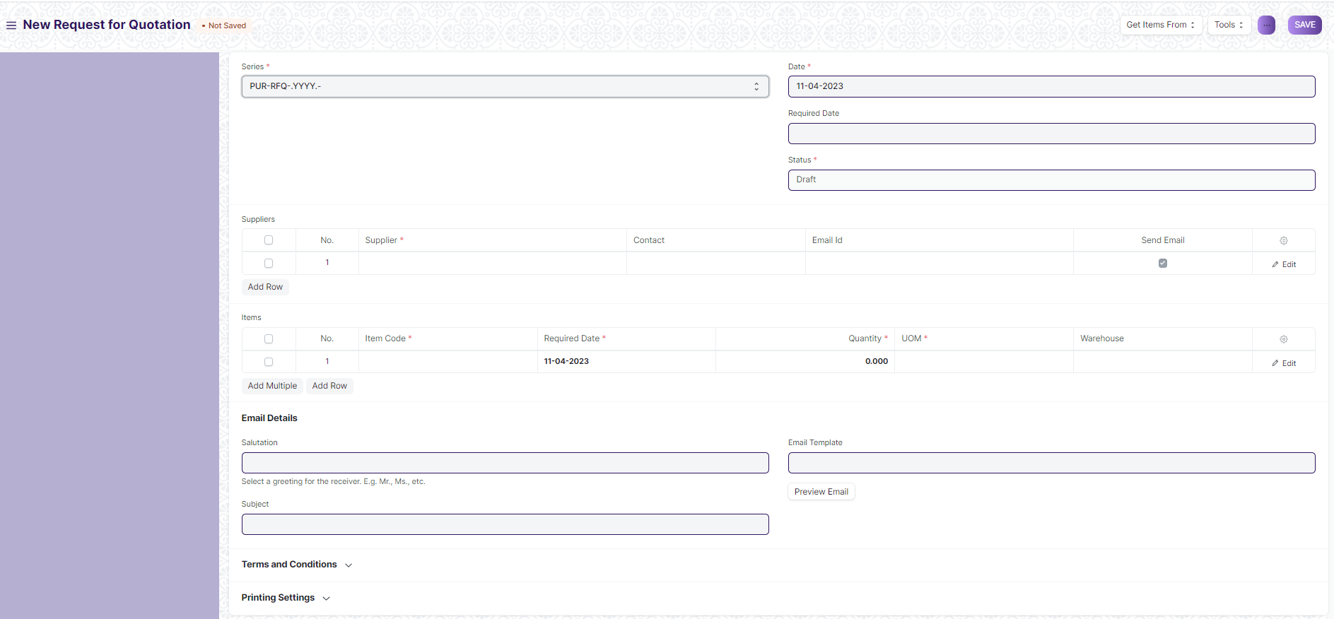

Fig: Request for Quotation

**UI Fields**

The “Request for Quotation” screen shall consist of the following fields:

|  |  |  |  |  |  |
| --- | --- | --- | --- | --- | --- |
| **Field Label** | **Field Type** | **Validation/Action** | **Mandatory** | **Remarks** | **R/N/D** |
| Series | Dropdown | PUR-RFQ-.YYYY.-(User will not able to change) | Yes |  |  |
| Company | Link | Value will fetch from Company | Yes |  |  |
| Date | Date Picker | Date will auto fetch but user can able to change | Yes |  |  |
| Required Date | Date Picker | User will give date |  |  |  |
| Status | Dropdown | * Draft * Submitted * Cancelled   (It will auto fetch according to the form condition) | Yes |  |  |
| **Suppliers** | **Table** |  | Yes | This table is describe below |  |
| **Items** | **Table** |  | Yes | This table is describe below |  |
| Salutation | Link | Value will fetch from Salutation and User will select any one |  |  |  |
| Subject | Text Field | User will give Input |  |  |  |
| Email Template | Link | Value will fetch from Email Template and User will select any one |  |  |  |
| Preview Email | Button | User will click button for previewing a email |  |  |  |
| Message for Supplier | Text Editor | User will give input | Yes |  |  |
| Incoterm | Link | Value will fetch from Incoterm and User will select any one |  |  |  |
| Named Place | Text Field | User will give input |  |  |  |
| Terms | Link | Value will fetch from Terms and User will select any one |  |  |  |
| Terms and Conditions | Text Editor | User will give input |  |  |  |
| Print Heading | Link | Value will fetched from Printing Head and user will select any one |  |  |  |
| Letter Head | Link | Value will fetched from Letter Head and user will select any one |  |  |  |
| Create | Button | Supplier Quotation: On click of this button you will be able to create supplier quotation for the selected RFQ |  |  |  |
| Tools | Button | Send Emails to supplier: On click of this button you will be able to send the RFQ to vendor via email |  |  |  |
| Download PDF: On click of this button you will be able to download the PDF version of the RFQ you have created |  |  |  |
| **Suppliers (Child Table)** | | | | | |
| **Field Label** | **Field Type** | **Validation/Action** | **Mandatory** | **Remarks** | **R/N/D** |
| Supplier | Link | Value will fetch from Supplier and User will select any one | Yes |  |  |
| Contact | Link | Value will fetch from Contact and User will select any one |  |  |  |
| Quote Status | Dropdown | * Pending * Received   (It will auto fetch) |  |  |  |
| Supplier Name | Read Only | Value will fetch according to supplier field |  |  |  |
| Email Id | Text Field | User will give input |  |  |  |
| Send Email | Checkbox | If checked then mail will triggered to supplier |  |  |  |
| Email Sent | Checkbox | When Mail triggered then here show as checked |  |  |  |
| **Items (Child Table)** | | | | | |
| **Field Label** | **Field Type** | **Validation/Action** | **Mandatory** | **Remarks** | **R/N/D** |
| Item Code | Link | Value will fetched from Item and user will select any one | Yes |  |  |
| Item Name | Text Field | Value will fetch when user will give Item Code field input but user can edit |  |  |  |
| Required Date | Date Picker | User will give date | Yes |  |  |
| Description | Text Editor | Value will fetch when user will give Item Code field input but user can edit | Yes |  |  |
| Item Group | Link (Read Only) | Value will fetch when user will give Item Code field input |  |  |  |
| Brand | Link (Read Only) | Value will fetch when user will give Item Code field input |  |  |  |
| Image View | Image | Value will fetch when user will give Item Code field input |  |  |  |
| Quantity | Number | Value will fetch when user will give Item Code field input but user can edit | Yes |  |  |
| Stock UOM | Link (Read Only) | Value will fetch when user will give Item Code field input | Yes |  |  |
| UOM | Link | Value will fetch from UOM when user will give Item code field input | Yes |  |  |
| UOM Conversion Factor | Number (Read Only) | Value will fetch when user will give Item Code field input |  |  |  |
| Qty as per Stock UOM | Number (Read Only) | Value will fetch when user will give Item Code field input |  |  |  |
| Warehouse | Link | Value will fetch from Warehouse when user will give Item code field input |  |  |  |
| Material Request | Link (Read Only) | Value will fetch when user will give Item Code field input |  |  |  |
| Project | Link | Value will fetch from Project |  |  |  |
| Page Break | Checkbox | If checked then Page Break will create a page break just before this item when printing |  |  |  |

**Users: Roles and Permissions**

The following table describes the users and their roles and permissions for the screens :

|  |  |  |  |  |  |  |  |  |  |
| --- | --- | --- | --- | --- | --- | --- | --- | --- | --- |
| **ID** | **Role** | **Select** | **Read** | **Write** | **Create** | **Delete** | **Submit** | **Cancel** | **Amend** |
|  | GM-Procurement & Contract Management | Yes | Yes | Yes | Yes | Yes | Yes | Yes | Yes |
|  | Purchase Manager | NA | Yes | Yes | Yes | Yes | Yes | Yes | Yes |

### 2.3 Supplier Quotation

**General Description**

The Following table describe overall information about this screen:

|  |  |
| --- | --- |
| **Description :** | 1. **A Supplier Quotation is document by a potential supplier specifying the cost of goods or services they'll provide within a specified period.** |
| **Navigation :** | Home > Material Management > Buying > Supplier Quotation |
| **Pre-requisites :** | 1. Supplier 2. Item |

**Supplier Quotation Screenshot**

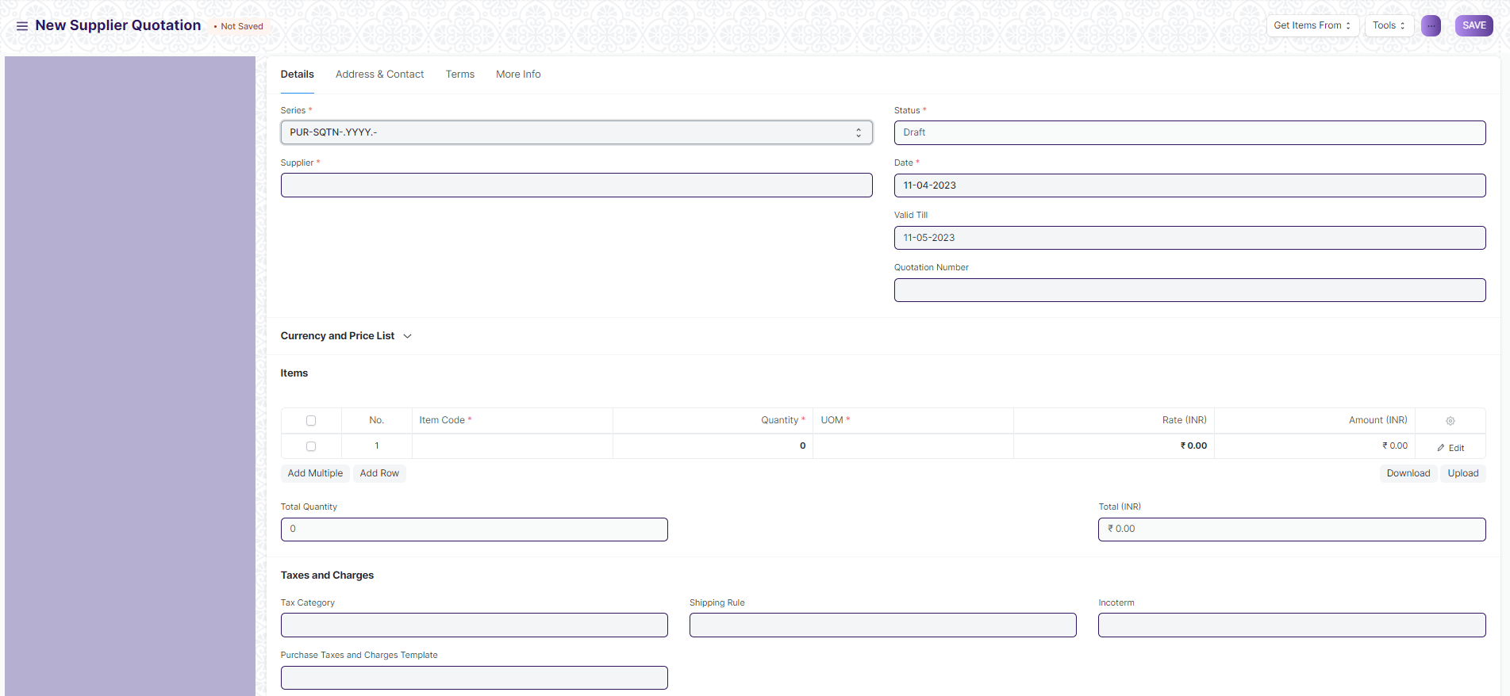

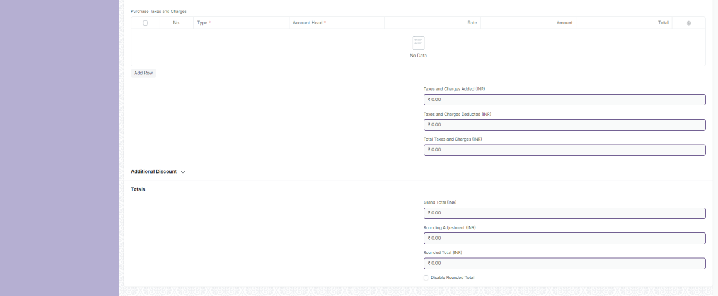



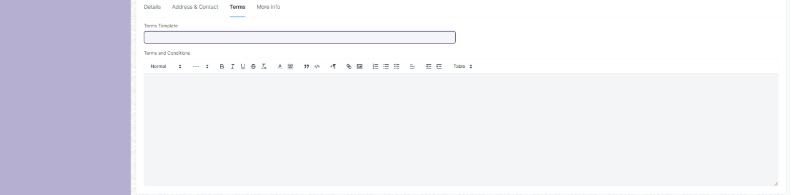



Fig: Supplier Quotation

**UI Fields**

The “Supplier Quotation” screen shall consist of the following fields:

|  |  |  |  |  |  |
| --- | --- | --- | --- | --- | --- |
| **Field Label** | **Field Type** | **Validation/Action** | **Mandatory** | **Remarks** | **R/N/D** |
| **Details (Tab Break)** | | | | | |
| Series | Dropdown | PUR-SQTN-.YYYY.-(User will not able to change) | Yes |  |  |
| Supplier | Link | Value will fetched from Supplier and user will select any one | Yes |  |  |
| Supplier Name | Text Field (Read only) | Value will auto fetch when supplier field value given |  |  |  |
| Company | Link | Value will fetch from Company | Yes |  |  |
| Status | Dropdown (Read only) | * Draft * Submitted * Stopped * Cancelled * Expired   (It will auto fetch according to the form condition) | Yes |  |  |
| Date | Date Picker | Date will auto fetch but user can able to change | Yes |  |  |
| Valid Till | Date Picker | Date will auto fetch but user can able to change |  |  |  |
| Quotation Number | Text Field | User will give Input |  |  |  |
| Currency | Link | Currency will auto fetch but user can able to change | Yes |  |  |
| Exchange Rate | Number | When you select other Country currency then this field will fetch and value will given but user can able to change | Yes |  |  |
| Price List | Link | Value will fetch from Price list |  |  |  |
| Price List Currency | Link (Read only) | Value will fetch from currency when Price List field value are given and Price List form value are for other country |  |  |  |
| Price List Exchange Rate | Number | Field are visible when Price List field value are given and Price List form value are given for other country and User can able to change the value |  |  |  |
| Ignore Pricing Rule | Checkbox | If checked then it ignore pricing rule |  |  |  |
| **Items** | **Table** |  | Yes | This table is describe below |  |
| Total Quantity | Number (Read only) | Value will fetch according to Item child table field value. |  |  |  |
| Total Net Weight | Number (Read only) | Value will fetch according to Item child table field value. |  |  |  |
| Total (Company Currency) | Currency (Read only) | Value will fetch according to Item child table field value. |  |  |  |
| Net Total (Company Currency) | Currency (Read only) | Value will fetch according to Item child table field value. |  |  |  |
| Total | Currency (Read only) | Value will fetch according to Item child table field value. |  |  |  |
| Net Total | Currency (Read only) | Value will fetch according to Item child table field value. |  |  |  |
| Tax Category | Link | Value will fetched from Tax Category and user will select any one |  |  |  |
| Purchase Taxes and Charges Template | Link | Value will fetched from Purchase Taxes and Charges Template and user will select any one |  |  |  |
| Shipping Rule | Link | Value will fetched from Shipping Rule and user will select any one |  |  |  |
| Incoterm | Link | Value will fetched from Incoterm and user will select any one |  |  |  |
| Named Place | Text Field | Field will visible when Incoterm value given. User will give input |  |  |  |
| **Purchase Taxes and Charges** | **Table** | Value will fetch according to “Purchase Taxes and Charges Template” field value |  | This table is describe below for manual process |  |
| Taxes and Charges Added (Company Currency) | Currency (Read only) | Value will fetch according to “Purchase Taxes and Charges”child table field value. |  |  |  |
| Taxes and Charges Deducted (Company Currency) | Currency (Read only) | Value will fetch according to “Purchase Taxes and Charges”child table field value. |  |  |  |
| Total Taxes and Charges (Company Currency) | Currency (Read only) | Value will fetch according to “Purchase Taxes and Charges”child table field value. |  |  |  |
| Taxes and Charges Added | Currency (Read only) | Value will fetch according to “Purchase Taxes and Charges”child table field value. |  |  |  |
| Taxes and Charges Deducted | Currency (Read only) | Value will fetch according to “Purchase Taxes and Charges”child table field value. |  |  |  |
| Total Taxes and Charges | Currency (Read only) | Value will fetch according to “Purchase Taxes and Charges”child table field value. |  |  |  |
| Apply Additional Discount On | Dropdown | * Grand Total * Net Total   (Grand Total are default value but user can able to change into Net Total) |  |  |  |
| Additional Discount Amount (Company Currency) | Currency (Read only) | Value will auto fetch according to discount |  |  |  |
| Additional Discount Percentage | Number | Value will give Input |  |  |  |
| Additional Discount Amount | Currency | Value will give Input |  |  |  |
| Grand Total (Company Currency) | Currency (Read only) | Value will fetch automatically according to other field |  |  |  |
| Rounding Adjustment (Company Currency | Currency (Read only) | Value will fetch automatically according to other field |  |  |  |
| Rounded Total (Company Currency) | Currency (Read only) | Value will fetch automatically according to other field |  |  |  |
| In Words (Company Currency) | Text Field (Read only) | Value will fetch automatically according to Grand Total field |  |  |  |
| Grand Total | Currency (Read only) | Value will fetch automatically according to other field |  |  |  |
| Rounding Adjustment | Currency (Read only) | Value will fetch automatically according to other field |  |  |  |
| Rounded Total | Currency (Read only) | Value will fetch automatically according to other field |  |  |  |
| In Words | Text Field (Read only) | Value will fetch automatically according to other field |  |  |  |
| Disable Rounded Total | Checkbox | If checked, Rounding Adjustment is not applicable |  |  |  |
| Taxes and Charges Calculation | Long Text (Read only) | Value will be fetched automatically according to other fields after being submitted |  |  |  |
| **Pricing Rule Detail** | **Table** |  |  | This table is described below |  |
| **Address & Contact (Tab Break)** | | | | | |
| Supplier Address | Link | Value will be fetched from an address and the user will select any one |  |  |  |
| Address | Small Text (Read only) | Value will fetch when Supplier Address field value is given |  |  |  |
| Contact Person | Link | Value will be fetched from Contact and the user will select any one |  |  |  |
| Contact | Small Text (Read only) | Value will be fetched when Contact Person field value is given |  |  |  |
| Mobile No | Small Text (Read only) | Value will be fetched when Contact Person field value is given |  |  |  |
| Contact Email | Text Field (Read only) | Value will be fetched when Contact Person field value is given |  |  |  |
| **Terms (Tab Break)** | | | | | |
| Terms Template | Link | Value will be fetched from “Terms and Conditions” and the user will select any one |  |  |  |
| Terms and Conditions | Text Editor | Value will be fetched when the “Terms and Conditions” field value is given and the user will be able to edit |  |  |  |
| **More Info (Tab Break)** | | | | | |
| Letter Head | Link | Value will be fetched from Letter Head and the user will select any one |  |  |  |
| Group same items | Checkbox | If checked then grouped same item |  |  |  |
| Print Heading | Link | Value will be fetched from Print Heading and the user will select any one |  |  |  |
| Print Language | Text Field (Read only) | Value will be fetched when given a supplier name In supplier field |  |  |  |
| Auto Repeat | Link (Read only) | Auto Repeat the supplier quotation at specified intervals.(After submitting the form it will be viable) |  |  |  |
| Update Auto Repeat Reference | Button | When value are present in Auto Repeat field then this button is visible. user will click and update Auto Repeat |  |  |  |
| Is Subcontracted | Checkbox | If checked then sub contract is applicable |  |  |  |
| Opportunity | Link (Read only) |  |  | It is for a selling module | D |
| Create | Button | Purchase Order: On clicking of this button you will be able to create a purchase order for the supplier quotation |  |  |  |
| Button | Quotation: On clicking of this button you will be able to create a quotation for the supplier quotation |  | It is for selling module | D |
| **Items (Child Table)** | | | | | |
| **Field Label** | **Field Type** | **Validation/Action** | **Mandatory** | **Remarks** | **R/N/D** |
| Item Code | Link | Value will be fetched from Item and user will select any one | Yes |  |  |
| Item Name | Text Field | Value will be fetched when user will give Item Code field input but user can edit |  |  |  |
| Supplier Lead Time (days) | Number | User will give input |  |  |  |
| Expected Delivery Date | Date Picker | User will give date |  |  |  |
| Is Free Item | Checkbox (Read Only) | Value will fetch when user will give Item Code field input |  |  |  |
| Description | Text Editor | Value will fetch when user will give Item Code field input but user can edit | Yes |  |  |
| HSN/SAC | Text Field | Value will fetch when user will give Item Code field input but user can edit |  |  |  |
| Is Nil Rated or Exempted | Checkbox | If checked, for an Item that is under GST, but no tax is applied |  |  |  |
| Is Non GST | Checkbox | If checked, For an item that is not covered under GST |  |  |  |
| Item Group | Link (Read Only) | Value will fetch when user will give Item Code field input |  |  |  |
| Brand | Link (Read Only) | Value will fetch when user will give Item Code field input |  |  |  |
| Image View | Image | Image will fetch when user will give Item Code field input |  |  |  |
| Quantity | Number | Value will fetch when user will give Item Code field input but user can edit | Yes |  |  |
| Stock UOM | Link (Read Only) | Value will fetch when user will give Item Code field input | Yes |  |  |
| UOM | Link | Value will fetch when user will give Item Code field input but user can edit | Yes |  |  |
| UOM Conversion Factor | Number (Read Only) | Value will fetch when user will give Item Code field input | Yes |  |  |
| Qty as per Stock UOM | Number (Read Only) | Value will fetch when user will give Item Code field input |  |  |  |
| Price List Rate | Currency | Value will fetch when user will give Item Code field input but user can edit |  |  |  |
| Discount on Price List Rate (%) | Percent | Value will fetch when user will give Item Code field input but user can edit |  |  |  |
| Discount Amount | Currency | Value will fetch when user will give Item Code field input but user can edit |  |  |  |
| Price List Rate (Company Currency) | Currency (Read Only) | Value will fetch when user will give Item Code field input |  |  |  |
| Rate | Currency | Value will fetch when user will give Item Code field input but user can edit |  |  |  |
| Amount | Currency (Read Only) | Value will fetch when user will give Item Code field input |  |  |  |
| Item Tax Template | Link | Value will fetched from Item Tax Template and user will select any one |  |  |  |
| Rate (Company Currency) | Currency (Read Only) | Value will fetch when user will give Item Code field input | Yes |  |  |
| Amount (Company Currency) | Currency (Read Only) | Value will fetch when user will give Item Code field input | Yes |  |  |
| Net Rate | Currency (Read Only) | Value will fetch when user will give Item Code field input |  |  |  |
| Net Amount | Currency (Read Only) | Value will fetch when user will give Item Code field input |  |  |  |
| Net Rate (Company Currency) | Currency (Read Only) | Value will fetch when user will give Item Code field input |  |  |  |
| Net Amount (Company Currency) | Currency (Read Only) | Value will fetch when user will give Item Code field input |  |  |  |
| Weight Per Unit | Number (Read Only) | Value will fetch when user will give Item Code field input |  |  |  |
| Total Weight | Number (Read Only) | Value will fetch when user will give Item Code field input |  |  |  |
| Weight UOM | Link (Read Only) | Value will fetch when user will give Item Code field input |  |  |  |
| Warehouse | Link | Value will fetch when user will give Item Code field input but user can edit |  |  |  |
| Material Request | Link (Read Only) | Value will fetch when user will give Item Code field input |  |  |  |
| Sales Order | Link (Read Only) | Value will fetch when user will give Item Code field input |  |  |  |
| Request for Quotation | Link (Read Only) | Value will fetch when user will give Item Code field input |  |  |  |
| Manufacturer | Link | Value will fetched from Manufacturer and user will select any one |  | It is for a Manufacture module | D |
| Manufacturer Part Number | Text Field | Value will fetch when user will give Manufacturer field input but user can edit |  | It is for a Manufacture module | D |
| Project | Link | Value will fetched from Project and user will select any one |  |  |  |
| Page Break | Checkbox | If checked then Page Break will create a page break just before this item when printing |  |  |  |
| **Purchase Taxes and Charges (Child Table)** | | | | | |
| **Field Label** | **Field Type** | **Validation/Action** | **Mandatory** | **Remarks** | **R/N/D** |
| Consider Tax or Charge for | Dropdown | * Valuation and Total * Valuation * Total   (“Total” are default value but user can able to change into “Valuation and Total”  or “Valuation”) | Yes |  |  |
| Add or Deduct | Dropdown | * Add * Deduct   (“Add” are default value but user can able to change into “Deduct”) | Yes |  |  |
| Type | Dropdown | * Actual * On Net Total * On Previous Row Amount * On Previous Row Total * On Item Quantity   (“On Net Total”are default value but user can able to change into other) | Yes |  |  |
| Reference Row # | Text Field | If tax is based on "Previous Row Total" User can select the row number which will be taken as a base for this calculation |  |  |  |
| Is this Tax included in Basic Rate? | Checkbox | If checked, the tax amount will be considered as already included in the Print Rate / Print Amount |  |  |  |
| Considered In Paid Amount | Checkbox | If checked, considered in paid amount |  |  |  |
| Account Head | Link | Value will fetched from Account and user will select any one | Yes |  |  |
| Description | Small Text | Value will auto fetch when we give value in Account Head field but user can edit | Yes |  |  |
| Rate | Number | Value will auto fetch when we give value in Account Head field but user can edit |  |  |  |
| Address | Link | Value will fetch from Address and user will select any one |  |  |  |
| Article | Link | Value will fetch from Article and user will select any one |  |  |  |
| Cost Center | Link | Value will auto fetch when we give value in Account Head field but user can edit |  |  |  |
| About Us Team Member | Link |  |  | It’s not link with any form,  Value will not fetch from anywhere | D |
| Account Currency | Link (Read Only) | Value will auto fetch when we give value in Account Head field |  |  |  |
| Amount | Currency | Value will auto fetch when we give value in Account Head field but user can edit |  |  |  |
| Tax Amount After Discount Amount | Currency (Read Only) | Value will auto fetch when we give value in Account Head field but user can edit |  |  |  |
| Total | Currency (Read Only) | Value will auto fetch when we give value in Account Head field but user can edit |  |  |  |
| Amount (Company Currency) | Currency (Read Only) | Value will auto fetch when we give value in Account Head field but user can edit |  |  |  |
| Tax Amount After Discount Amount | Currency (Read Only) | Value will auto fetch when we give value in Account Head field but user can edit |  |  |  |
| **Pricing Rule Detail (Child Table)** | | | | | |
| **Field Label** | **Field Type** | **Validation/Action** | **Mandatory** | **Remarks** | **R/N/D** |
| Pricing Rule | Link | Value will auto fetch from Pricing Rule if it is applicable for account |  |  |  |
| Item Code | Text Field | Value will auto fetch according Pricing Rule |  |  |  |
| Rule Applied | Checkbox | If Checked, rule will applied for account pricing |  |  |  |

**Users: Roles and Permissions**

The following table describes the users and their roles and permissions for the screens :

|  |  |  |  |  |  |  |  |  |  |
| --- | --- | --- | --- | --- | --- | --- | --- | --- | --- |
| **ID** | **Role** | **Select** | **Read** | **Write** | **Create** | **Delete** | **Submit** | **Cancel** | **Amend** |
|  | GM-Procurement & Contract Management | Yes | Yes | Yes | Yes | Yes | Yes | Yes | Yes |
|  | Purchase Manager | Yes | Yes | Yes | Yes | Yes | Yes | Yes | Yes |

### 2.4 Purchase Order

**General Description**

The following table describes overall information about this screen:

|  |  |
| --- | --- |
| **Description :** | 1. **A Purchase Order is a binding contract with your Supplier that you promise to buy a set of items under given conditions.** |
| **Navigation :** | Home > Material Management > Buying > Purchase Order |
| **Pre-requisites :** | 1. Supplier 2. Item |

**Purchase Order Screenshot**

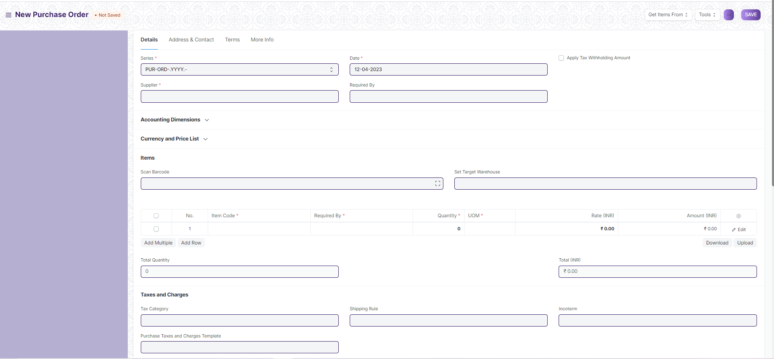

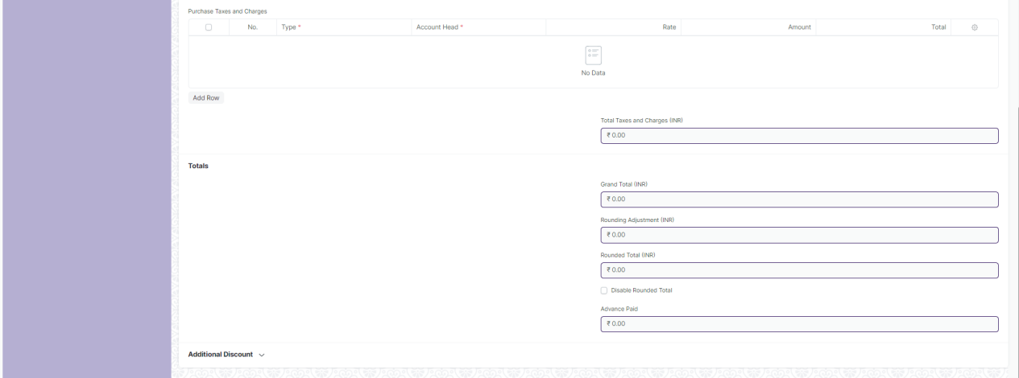

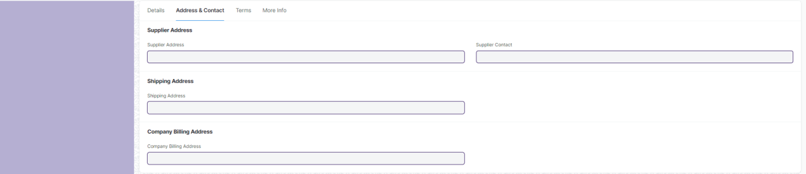

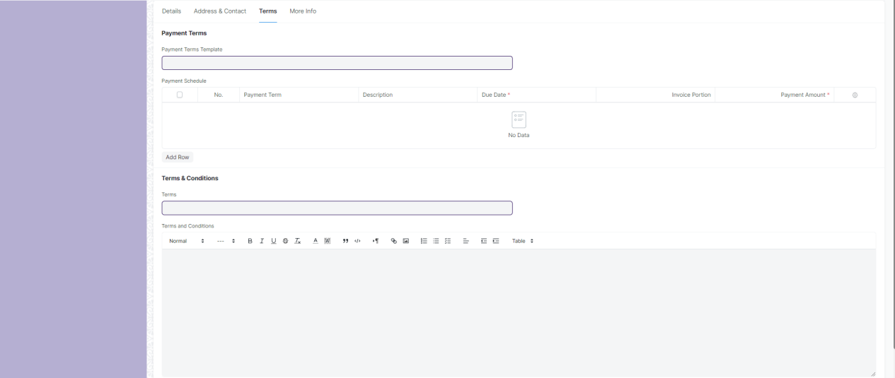

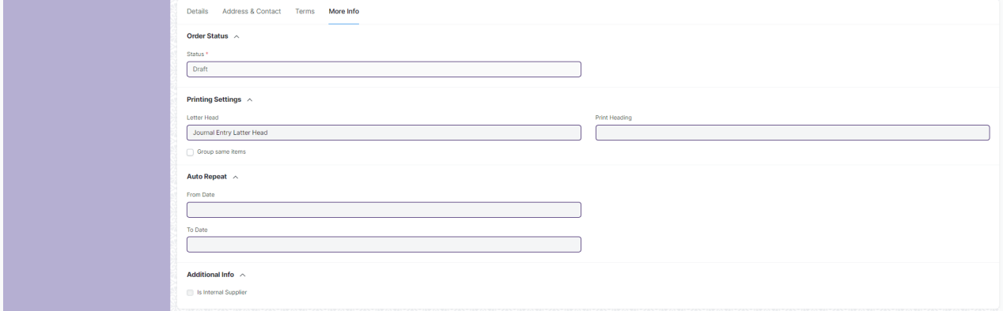

Fig: Purchase Order

**UI Fields**

The “Purchase Order” screen shall consist of the following fields:

|  |  |  |  |  |  |
| --- | --- | --- | --- | --- | --- |
| **Field Label** | **Field Type** | **Validation/Action** | **Mandatory** | **Remarks** | **R/N/D** |
| **Details (Tab Break)** | | | | | |
| Series | Dropdown | PUR-ORD-.YYYY.-(User will not able to change) | Yes |  |  |
| Supplier | Link | Value will fetched from Supplier and user will select any one | Yes |  |  |
| Supplier Name | Text Field (Read Only) | Value will auto fetch when Supplier field value given |  |  |  |
| Order Confirmation No | Text Field | User will give input after submit |  |  |  |
| Order Confirmation Date | Date Picker | When user fill “Order Confirmation No” after that this field will visible and then user will give input |  |  |  |
| Get Items from Open Material Requests | Button | User will click on the ”**Get Items from open Material Requests”** button below the Supplier name. Now a dialog will appear with Material Requests containing Items for which the default Supplier is the same as the one selected in the Purchase Order. On selecting the Material Requests and clicking on **Get Items**, the Items will be fetched from the Material Requests. |  | This button only visible when user will do manual entry when we give value in Supplier field |  |
| Date | Date Picker | Date will auto fetch but user can able to change | Yes |  |  |
| Required By | Date Picker | User will give input |  |  |  |
| Company | Link | Value will fetch from Company | Yes |  |  |
| Apply Tax Withholding Amount | Checkbox | If checked then Tax Withholding category will required |  |  |  |
| Tax Withholding Category | Link | Value will fetched from “Tax Withholding category” and user will select any one |  |  |  |
| Cost Center | Link | Value will fetched from Cost Center and user will select any one |  |  |  |
| Currency | Link | Currency will auto fetch but user can able to change | Yes |  |  |
| Exchange Rate | Number | When you select other Country currency then this field will fetch and value will given but user can able to change | Yes |  |  |
| Price List | Link | Value will fetch from Price list |  |  |  |
| Price List Currency | Link (Read Only) | Value will fetch from currency when Price List field value are given and Price List form value are given for other country |  |  |  |
| Price List Exchange Rate | Number | Field are visible when Price List field value are given and Price List form value are given for other country and User can able to change the value |  |  |  |
| Ignore Pricing Rule | Checkbox | If checked then it ignore pricing rule |  |  |  |
| Scan Barcode | Text Field | User will give input. By Reader or camera user will also give input |  |  |  |
| Set From Warehouse | Link | Value will fetched from Warehouse and user will select any one |  |  |  |
| Set Target Warehouse | Link | Value will fetched from Warehouse and user will select any one |  |  |  |
| **Item** | **Table** |  | Yes | This table is describe below |  |
| Total Quantity | Number (Read Only) | Value will fetch according to Item child table field value. |  |  |  |
| Total Net Weight | Number (Read Only) | Value will fetch according to Item child table field value. |  |  |  |
| Total (Company Currency) | Currency (Read Only) | Value will fetch according to Item child table field value. |  |  |  |
| Net Total (Company Currency) | Currency (Read Only) | Value will fetch according to Item child table field value. |  |  |  |
| Total | Currency (Read Only) | Value will fetch according to Item child table field value. |  |  |  |
| Net Total | Currency (Read Only) | Value will fetch according to Item child table field value. |  |  |  |
| **Purchase Order Pricing Rule** | **Table (Read Only)** | Auto fetch according to Pricing rule |  | This table is describe below |  |
| Set Reserve Warehouse | Link | Field will fetch when Supplier Item given. Value will fetched from Warehouse and user will select any one |  |  |  |
| **Supplied Items** | **Table (Read Only)** | Auto fetch according to Supplied Items |  | This table is describe below |  |
| Tax Category | Link | Value will fetched from Tax Category and user will select any one |  |  |  |
| Purchase Taxes and Charges Template | Link | Value will fetched from Purchase Taxes and Charges Template and user will select any one |  |  |  |
| Shipping Rule | Link | Value will fetched from Shipping Rule and user will select any one |  |  |  |
| Incoterm | Link | Value will fetched from Incoterm and user will select any one |  |  |  |
| Named Place | Text Field | Field will visible when Incoterm value given. User will give input |  |  |  |
| **Purchase Taxes and Charges** | **Table** | Value will fetch according to “Purchase Taxes and Charges Template” field value |  | This table is describe below for manual process |  |
| Taxes and Charges Added (Company Currency) | Currency (Read Only) | Value will fetch according to “Purchase Taxes and Charges”child table field value. |  |  |  |
| Taxes and Charges Deducted (Company Currency) | Currency (Read Only) | Value will fetch according to “Purchase Taxes and Charges”child table field value. |  |  |  |
| Total Taxes and Charges (Company Currency) | Currency (Read Only) | Value will fetch according to “Purchase Taxes and Charges”child table field value. |  |  |  |
| Taxes and Charges Added | Currency (Read Only) | Value will fetch according to “Purchase Taxes and Charges”child table field value. |  |  |  |
| Taxes and Charges Deducted | Currency (Read Only) | Value will fetch according to “Purchase Taxes and Charges”child table field value. |  |  |  |
| Total Taxes and Charges | Currency (Read Only) | Value will fetch according to “Purchase Taxes and Charges”child table field value. |  |  |  |
| Grand Total (Company Currency) | Currency (Read Only) | Value will fetch automatically according to other field |  |  |  |
| Rounding Adjustment (Company Currency) | Currency (Read Only) | Value will fetch automatically according to other field |  |  |  |
| In Words (Company Currency) | Text Field (Read Only) | Value will fetch automatically according to Grand Total (Company Currency) field |  |  |  |
| Rounded Total (Company Currency) | Currency (Read Only) | Value will fetch automatically according to other field |  |  |  |
| Grand Total | Currency (Read Only) | Value will fetch automatically according to other field |  |  |  |
| Rounding Adjustment | Currency (Read Only) | Value will fetch automatically according to other field |  |  |  |
| Rounded Total | Currency (Read Only) | Value will fetch automatically according to other field |  |  |  |
| Disable Rounded Total | Checkbox | If checked Rounding Adjustment is not applicable |  |  |  |
| In Words | Text Field (Read Only) | Value will fetch automatically according to Grand Total field |  |  |  |
| Advance Paid | Currency (Read Only) | Value will auto fetch when payment is done in advance |  |  |  |
| Apply Additional Discount On | Dropdown | * Grand Total * Net Total   (Grand Total are default value but user can able to change into Net Total) |  |  |  |
| Additional Discount Amount (Company Currency) | Currency (Read Only) | Value will auto fetch according to discount |  |  |  |
| Additional Discount Percentage | Number | User will give Input |  |  |  |
| Additional Discount Amount | Currency | User will give Input |  |  |  |
| Taxes and Charges Calculation | Long Text (Read Only) | After all tax calculation value will auto fetch |  |  |  |
| **Address & Contact (Tab Break)** | | | | | |
| Supplier Address | Link | After selecting the Supplier, this value will be auto fetch but user can able to edit |  |  |  |
| Supplier Address Details | Small Text (Read Only) | After selecting the Supplier, this value will be auto fetch. |  |  |  |
| Supplier GSTIN | Text Field (Read Only) | After selecting the Supplier, this value will be auto fetch |  |  |  |
| GST Category | Text Field (Read Only) | After selecting the Supplier, this value will be auto fetch |  |  |  |
| Supplier Contact | Link | After selecting the Supplier, this value will be auto fetch but user can able to edit |  |  |  |
| Contact Name | Small Text (Read Only) | After selecting the Supplier, this value will be auto fetch |  |  |  |
| Contact Mobile No | Small Text (Read Only) | After selecting the Supplier, this value will be auto fetch |  |  |  |
| Contact Email | Small Text (Read Only) | After selecting the Supplier, this value will be auto fetch |  |  |  |
| Shipping Address | Link | After selecting the Supplier, this value will be auto fetch but user can able to edit |  |  |  |
| Shipping Address Details | Small Text (Read Only) | After selecting the Supplier, this value will be auto fetch |  |  |  |
| Company Billing Address | Link | After selecting the Supplier, this value will be auto fetch but user can able to edit |  |  |  |
| Billing Address Details | Small Text (Read Only) | After selecting the Supplier, this value will be auto fetch |  |  |  |
| Company GSTIN | Text Field (Read Only) | After selecting the Supplier, this value will be auto fetch |  |  |  |
| Place of Supply | Text Field (Read Only) | After selecting the Supplier, this value will be auto fetch |  |  |  |
| **Drop Ship (Tab Break)** | | | | | |
| Customer | Link (Read Only) | If Purchase Order will done for Customer then this value will auto fetch from customer |  |  |  |
| Customer Name | Text Field (Read Only) | If Purchase Order will done for Customer then this value will auto fetch from customer |  |  |  |
| Customer Contact | Link | If Purchase Order will done for Customer then this value will auto fetch from Customer Contact and user can able to edit |  |  |  |
| Customer Contact | Small Text | If Purchase Order will done for Customer then this value will auto fetch from Customer Contact and user can able to edit |  |  |  |
| **Terms (Tab Break)** | | | | | |
| Payment Terms Template | Link | After selecting the Supplier, this value will be auto fetch but user can able to edit |  |  |  |
| **Payment Schedule** | **Table** | Value will fetch according to “Payment Terms Template” field value |  | This table is describe below for manual process |  |
| Terms | Link | Value will fetched from “Terms and Conditions” and user will select any one |  |  |  |
| Terms and Conditions | Text Editor | Value will fetch when “Terms and Conditions” field value given and User can able to edit |  |  |  |
| **More Info (Tab Break)** | | | | | |
| Status | Dropdown (Read Only) | * Draft * On Hold * To Receive and Bill * To Bill * To Receive * Completed * Cancelled * Closed * Delivered   (It will auto fetch according to the form condition) | Yes |  |  |
| % Billed | Percent (Read Only) | Value will auto fetch according to how many bill percent is completed for that Purchase order |  |  |  |
| % Received | Percent (Read Only) | Value will auto fetch according to how many received percent is completed Purchase order |  |  |  |
| Letter Head | Link | Value will fetched from Letter Head and user will select any one |  |  |  |
| Group same items | Checkbox | If checked then grouped same item |  |  |  |
| Print Heading | Link | Value will fetched from Print Heading and user will select any one |  |  |  |
| From Date | Date Picker | User will give date |  |  |  |
| To Date | Date Picker | User will give date |  |  |  |
| Auto Repeat | Link (Read Only) | Auto Repeat the Purchase order at specified intervals.(After submitting the form it will visible) |  |  |  |
| Update Auto Repeat Reference | Button | When value are present in Auto Repeat field then this button are visible. User will click and update Auto Repeat |  |  |  |
| Is Internal Supplier | Checkbox (Read Only) | If checked then supplier will be internal |  |  |  |
| Represents Company | Link (Read Only) | Value will auto fetch from Company |  |  |  |
| Supplier Quotation | Link (Read Only) | Value will auto fetch from Supplier Quotation |  |  |  |
| Inter Company Order Reference | Link (Read Only) | Value will auto fetch from Company |  |  |  |
| Status | Button | Hold: On click of this button you can change the Status of PO to Hold, after click on this button you will have to enter the reason for hold of PO enter and click on submit |  | You can resume it later if needed |  |
| Status | Button | Close: On click of this button you can change the Status of PO to Close |  | You can reopen closed PO’s if needed |  |
| Create | Button | Purchase Invoice: On click of this button you can create a Purchase Invoice for the PO selected |  |  |  |
| Create | Button | Payment: On click of this button you can create Payment entry for the PO, this is helpful in case of making advance payments |  |  |  |
| Create | Button | Payment request: On click of this button you can create payment request for the PO. |  |  |  |
| Create | Button | Subscription: On click of this button you can create subscription for a PO |  |  |  |
| **Items (Child Table)** | | | | | |
| **Field Label** | **Field Type** | **Validation/Action** | **Mandatory** | **Remarks** | **R/N/D** |
| Item Code | Link | Value will fetched from Item and user will select any one | Yes |  |  |
| Item Name | Text Field | Value will fetch when user will give Item Code field input but user can edit | Yes |  |  |
| Product Bundle | Link (Read Only) | Value will auto fetch from Product Bundle according to the Item |  |  |  |
| Finished Good Item | Link |  |  | Subcontracted is not applicable | D |
| Finished Good Item Qty | Number |  |  | Subcontracted is not applicable | D |
| Required By | Date Picker | Value will fetch when user will give Item Code field input but user can edit | Yes |  |  |
| Expected Delivery Date | Date Picker | Value will fetch when user will give Item Code field input but user can edit |  |  |  |
| Description | Text Editor | Value will fetch when user will give Item Code field input but user can edit | Yes |  |  |
| HSN/SAC | Text Field | Value will fetch when user will give Item Code field input but user can edit |  |  |  |
| Is Nil Rated or Exempted | Checkbox | Tax is not applicable if checked |  | Tax is applicable for all item | D |
| Is Non GST | Checkbox | If checked, For an item that is not covered under GST |  |  |  |
| Image View | Image | Image will fetch when user will give Item Code field input but user can edit |  |  |  |
| Quantity | Number | Value will fetch when user will give Item Code field input but user can edit | Yes |  |  |
| Stock UOM | Link (Read Only) | Value will fetch when user will give UOM field input | Yes |  |  |
| UOM | Link | Value will fetch when user will give Item Code field input but user can edit | Yes |  |  |
| UOM Conversion Factor | Number | Value will fetch when user will give UOM field input but user can edit | Yes |  |  |
| Qty in Stock UOM | Number (Read Only) | Value will fetch when user will give UOM field input |  |  |  |
| Price List Rate | Currency | Value will fetch when user will give Item Code field input but user can edit |  |  |  |
| Last Purchase Rate | Currency (Read Only) | Value will fetch when user will give Item Code field input |  |  |  |
| Price List Rate (Company Currency) | Currency (Read Only) | Value will fetch when user will give Item Code field input |  |  |  |
| Margin Type | Dropdown | * Percentage * Amount   (User will select one) |  |  |  |
| Margin Rate or Amount | Number | Field will visible when user will give input to Margin Type field |  |  |  |
| Rate With Margin | Currency (Read Only) | Field will visible when user will give input to Margin Rate or Amount field |  |  |  |
| Discount on Price List Rate (%) | Percent | User will give Input |  |  |  |
| Discount Amount | Currency | User will give Input |  |  |  |
| Rate With Margin (Company Currency) | Currency (Read Only) | Field will visible when user will give input to Margin Type field |  |  |  |
| Rate | Currency | Value will fetch when user will give Item Code field input but user can edit |  |  |  |
| Amount | Currency (Read Only) | Value will fetch when user will give Item Code field input |  |  |  |
| Item Tax Template | Link | Value will fetch when user will give Item Code field input but user can edit |  |  |  |
| Rate (Company Currency) | Currency (Read Only) | Value will fetch when user will give Item Tax Template field input | Yes |  |  |
| Amount (Company Currency) | Currency (Read Only) | Value will fetch when user will give Item Tax Template field input | Yes |  |  |
| Rate of Stock UOM | Currency (Read Only) | Value will fetch when user will give Item Tax Template field input |  |  |  |
| Is Free Item | Checkbox (Read Only) | If Checked, Item will be free of cost |  |  |  |
| Apply TDS | Checkbox | If Checked, TDS will applied for that item |  |  |  |
| Net Rate | Currency (Read Only) | Value will fetch when user will give Item Code field input |  |  |  |
| Net Amount | Currency (Read Only) | Value will fetch when user will give Item Code field input |  |  |  |
| Net Rate (Company Currency) | Currency (Read Only) | Value will fetch when user will give Item Code field input |  |  |  |
| Net Amount (Company Currency) | Currency (Read Only) | Value will fetch when user will give Item Code field input |  |  |  |
| From Warehouse | Link | Value will fetched from Warehouse and user will select any one |  |  |  |
| Target Warehouse | Link | Value will fetched from Warehouse and user will select any one |  |  |  |
| Available Qty at Target Warehouse | Number (Read Only) | Value will auto fetch according to Target warehouse value |  |  |  |
| Available Qty at Company | Number (Read Only) | Value will auto fetch according to Target warehouse value |  |  |  |
| Material Request | Link (Read Only) | Value will fetch when user will give Item Code field input |  |  |  |
| Sales Order | Link |  |  | It is for a Selling module | D |
| Sales Order Packed Item | Text Field |  |  | It is for a Selling module | D |
| Supplier Quotation | Link (Read Only) |  |  | It is for a Selling module | D |
| To be Delivered to Customer | Checkbox (Read Only) |  |  | It is for a Selling module | D |
| Against Blanket Order | Checkbox |  |  | It is for a Selling module | D |
| Blanket Order | Link |  |  | It is for a Selling module | D |
| Blanket Order Rate | Currency (Read Only) |  |  | It is for a Selling module | D |
| Received Qty | Number (Read Only) | Value will fetch when user will give Item Code field input |  |  |  |
| Returned Qty | Number (Read Only) | Value will fetch when user will give Item Code field input |  |  |  |
| Billed Amount | Currency (Read Only) | Value will fetch when user will give Item Code field input |  |  |  |
| Expense Account | Link | Value will fetched from Account and user will select any one |  |  |  |
| Manufacturer | Link |  |  | It is for a Manufacture module | D |
| Manufacturer Part Number | Text Field |  |  | It is for a Manufacture module | D |
| BOM | Link (Read Only) |  |  | It is for a Manufacture module | D |
| Include Exploded Items | Checkbox |  |  | It is for a Manufacture module | D |
| Weight Per Unit | Number (Read Only) | Value will fetched from Account and user will select any one |  |  |  |
| Total Weight | Number (Read Only) | Value will fetched from Account and user will select any one |  |  |  |
| Weight UOM | Link (Read Only) | Value will fetched from Account and user will select any one |  |  |  |
| Address | Link | Value will fetched from Address and user will select any one |  |  |  |
| Article | Link | Value will fetched from Article and user will select any one |  |  |  |
| Project | Link | Value will fetched from Project and user will select any one |  |  |  |
| About Us Team Member | Link |  |  | It’s not link with any form, Value will not fetch from anywhere | D |
| Cost Center | Link | Value will fetched from Cost Center and user will select any one |  |  |  |
| Is Fixed Asset | Checkbox (Read Only) | If Checked then item will be asset |  |  |  |
| Production Plan | Link (Read Only) |  |  | Production Plan not required | D |
| Page Break | Checkbox | If checked then Page Break will create a page break just before this item when printing |  |  |  |
| **Purchase Order Pricing Rule (Child Table)** | | | | | |
| **Field Label** | **Field Type** | **Validation/Action** | **Mandatory** | **Remarks** | **R/N/D** |
| Pricing Rule | Link | Value will auto fetch from Pricing Rule if it is applicable for account |  |  |  |
| Item Code | Text Field | Value will auto fetch according Pricing Rule |  |  |  |
| Rule Applied | Checkbox | If Checked, rule will applied for account pricing |  |  |  |
| **Supplied Items (Child Table)** | | | | | |
| **Field Label** | **Field Type** | **Validation/Action** | **Mandatory** | **Remarks** | **R/N/D** |
| Item Code | Link | Value auto fetch When transfer Material to Supplier |  |  |  |
| Raw Material Item Code | Link | Value auto fetch When transfer Material to Supplier |  |  |  |
| Stock Uom | Link | Value auto fetch When transfer Material to Supplier |  |  |  |
| Reserve Warehouse | Link | Value auto fetch When transfer Material to Supplier |  |  |  |
| BOM Detail No | Text Field |  |  | It is for a Manufacture module | D |
| Reference Name | Text Field | Value auto fetch When transfer Material to Supplier |  |  |  |
| Rate | Currency | Value auto fetch When transfer Material to Supplier |  |  |  |
| Amount | Currency | Value auto fetch When transfer Material to Supplier |  |  |  |
| Required Qty | Number | Value auto fetch When transfer Material to Supplier |  |  |  |
| Supplied Qty | Number | Value auto fetch When transfer Material to Supplier |  |  |  |
| Consumed Qty | Number | Value auto fetch When transfer Material to Supplier |  |  |  |
| Returned Qty | Number | Value auto fetch When transfer Material to Supplier |  |  |  |
| **Purchase Taxes and Charges (Child Table)** | | | | | |
| **Field Label** | **Field Type** | **Validation/Action** | **Mandatory** | **Remarks** | **R/N/D** |
| Consider Tax or Charge for | Dropdown | * Valuation and Total * Valuation * Total   (“Total” are default value but user can able to change into “Valuation and Total”  or “Valuation”) | Yes |  |  |
| Add or Deduct | Dropdown | * Add * Deduct   (“Add” are default value but user can able to change into “Deduct”) | Yes |  |  |
| Type | Dropdown | * Actual * On Net Total * On Previous Row Amount * On Previous Row Total * On Item Quantity   (“On Net Total”are default value but user can able to change into other) | Yes |  |  |
| Reference Row # | Text Field | If tax is based on "Previous Row Total" User can select the row number which will be taken as a base for this calculation |  |  |  |
| Is this Tax included in Basic Rate? | Checkbox | If checked, the tax amount will be considered as already included in the Print Rate / Print Amount |  |  |  |
| Considered In Paid Amount | Checkbox | If checked, considered in paid amount |  |  |  |
| Account Head | Link | Value will fetched from Account and user will select any one | Yes |  |  |
| Description | Small Text | Value will auto fetch when we give value in Account Head field but user can edit | Yes |  |  |
| Rate | Number | Value will auto fetch when we give value in Account Head field but user can edit |  |  |  |
| Address | Link | Value will fetched from Address and user will select any one |  |  |  |
| Article | Link | Value will fetched from Article and user will select any one |  |  |  |
| Cost Center | Link | Value will auto fetch when we give value in Account Head field but user can edit |  |  |  |
| About Us Team Member | Link |  |  | It’s not link with any form,  Value will not fetch from anywhere | D |
| Account Currency | Link (Read Only) | Value will auto fetch when we give value in Account Head field |  |  |  |
| Amount | Currency | Value will auto fetch when we give value in Account Head field but user can edit |  |  |  |
| Tax Amount After Discount Amount | Currency (Read Only) | Value will auto fetch when we give value in Account Head field but user can edit |  |  |  |
| Total | Currency (Read Only) | Value will auto fetch when we give value in Account Head field but user can edit |  |  |  |
| Amount (Company Currency) | Currency (Read Only) | Value will auto fetch when we give value in Account Head field but user can edit |  |  |  |
| Tax Amount After Discount Amount | Currency (Read Only) | Value will auto fetch when we give value in Account Head field but user can edit |  |  |  |
| **Payment Schedule (Child Table)** | | | | | |
| **Field Label** | **Field Type** | **Validation/Action** | **Mandatory** | **Remarks** | **R/N/D** |
| Payment Term | Link | Value will fetched from Payment Term and user will select any one |  |  |  |
| Description | Small Text | Value will give input |  |  |  |
| Due Date | Date Picker | Value will auto fetch when user give input in Payment Term field but user can able to edit | Yes |  |  |
| Mode of Payment | Link | Value will auto fetch when user give input in Payment Term field but user can able to edit |  |  |  |
| Invoice Portion | Percent | Value will auto fetch when user give input in Payment Term field but user can able to edit |  |  |  |
| Discount Type | Dropdown | * Percentage * Amount   (Percentage Is default value but user can change into Amount) |  |  |  |
| Discount Date | Date Picker | Value will auto fetch when user give input in Discount field but user can able to edit |  |  |  |
| Discount | Number | User will give Input |  |  |  |
| Payment Amount | Currency | Value will auto fetch when user give input in Payment Term field but user can able to edit | Yes |  |  |
| Outstanding | Currency (Read Only) | Value will auto fetch when user give input in Payment Term field |  |  |  |
| Paid Amount | Currency | Value will auto fetch when user give input in Payment Term field but user can able to edit |  |  |  |
| Discounted Amount | Currency (Read Only) | Value will auto fetch according to the discount |  |  |  |
| Payment Amount (Company Currency) | Currency | Value will auto fetch when user give input in Payment Term field but user can able to edit |  |  |  |

**Note:**

1. Report for L1 vendor selection will be created for issuesing PO based on L1 price
2. Print format to be developed for PO
3. Mail to be sent to supplier after 100% items are received for a PO

**Users: Roles and Permissions**

The following table describes the users and their roles and permissions for the screens :

|  |  |  |  |  |  |  |  |  |  |
| --- | --- | --- | --- | --- | --- | --- | --- | --- | --- |
| **ID** | **Role** | **Select** | **Read** | **Write** | **Create** | **Delete** | **Submit** | **Cancel** | **Amend** |
|  | GM-Procurement & Contract Management | Yes | Yes | Yes | Yes | Yes | Yes | Yes | Yes |
|  | Purchase Manager | Yes | Yes | Yes | Yes | Yes | Yes | Yes | Yes |

### 2.5 Purchase Receipt

**General Description**

|  |  |
| --- | --- |
| **Description :** | 1. **Purchase Receipts are made when you accept Items from your Supplier usually against a Purchase Order.** |
| **Navigation :** | Home > Material Management > Buying > Purchase Receipt |
| **Pre-requisites :** | 1. Purchase Order |

**Purchase Receipt Screenshot**

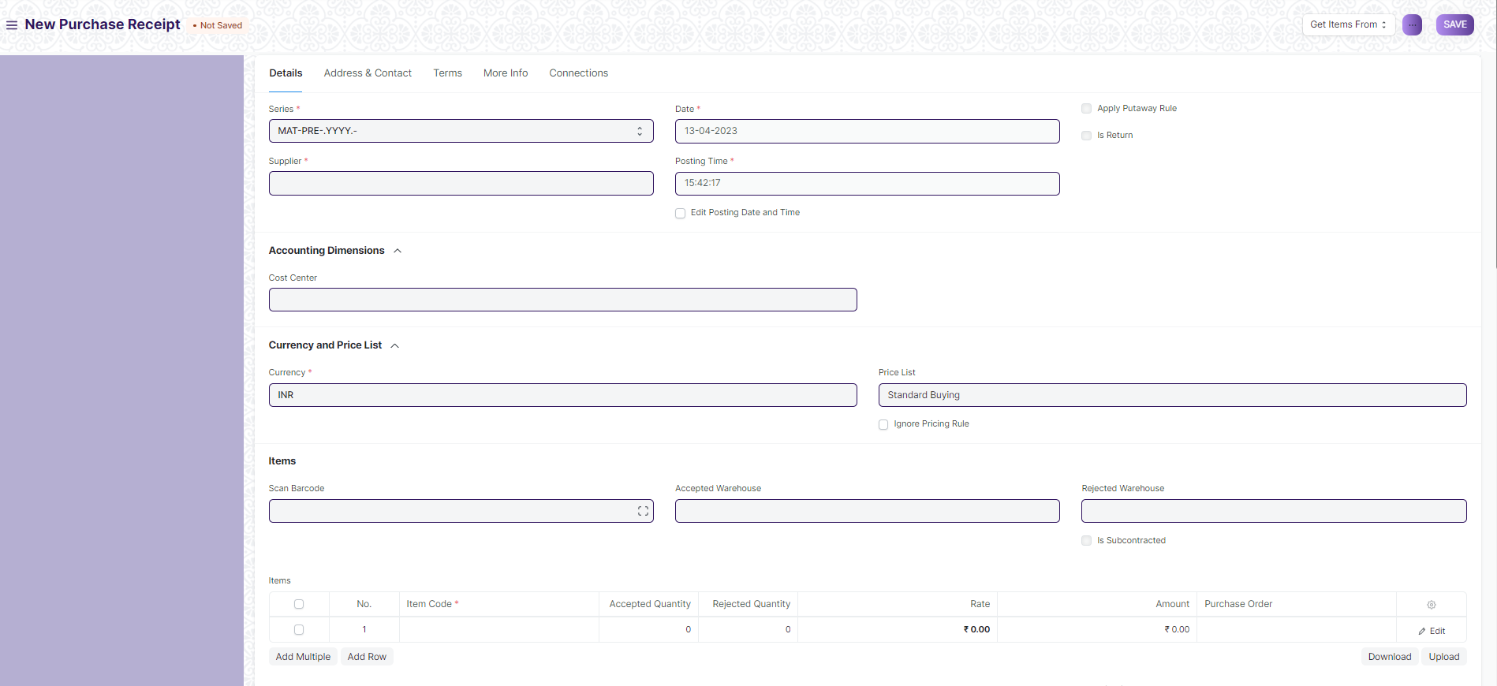

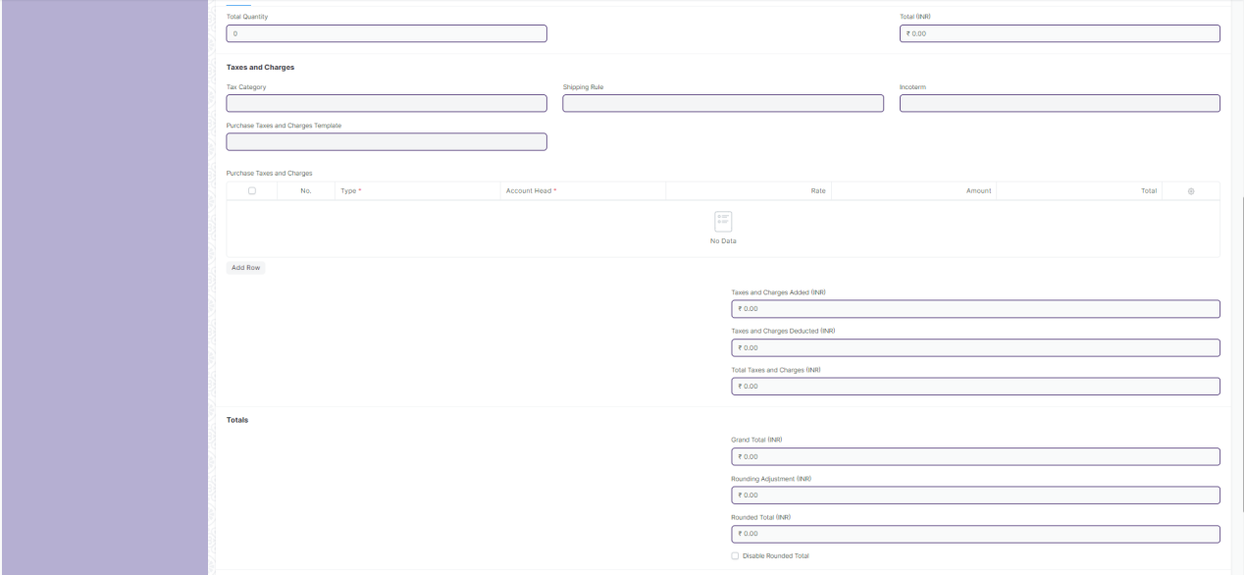



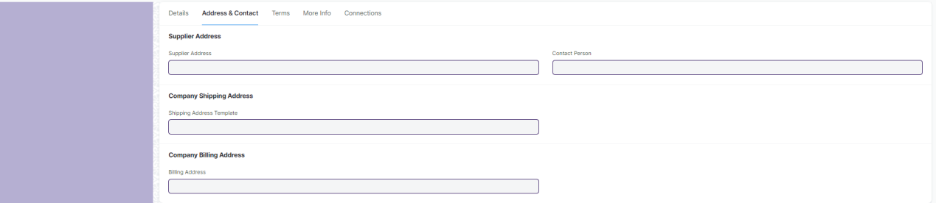

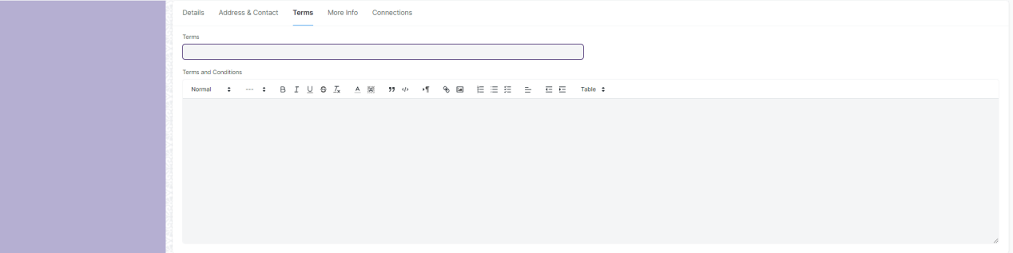

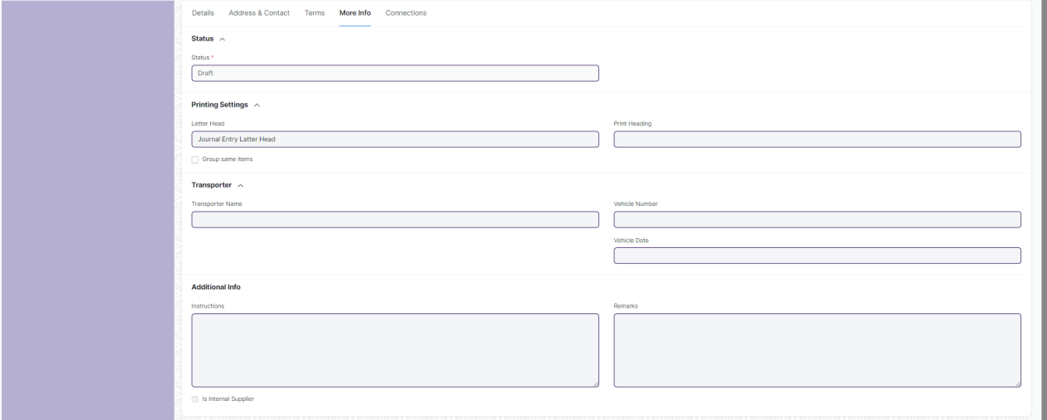



Fig: Purchase Receipt

**UI Fields**

The “Purchase Receipt” screen shall consist of the following fields:

|  |  |  |  |  |  |
| --- | --- | --- | --- | --- | --- |
| **Field Label** | **Field Type** | **Validation/Action** | **Mandatory** | **Remarks** | **R/N/D** |
| **Details (Tab Break)** | | | | | |
| Series | Dropdown | * MAT-PRE-.YYYY.- * MAT-PR-RET-.YYYY.-   (“MAT-PRE-.YYYY.-”are default value but user will select any one) | Yes |  |  |
| Supplier | Link | Value will fetched from Supplier and user will select any one | Yes |  |  |
| Supplier Name | Text Field (Read Only) | Value will auto fetch when Supplier field value given |  |  |  |
| Date | Date Picker | Value will auto fetch but user can able to edit If Checked “Edit Posting Date and Time” field | Yes |  |  |
| Posting Time | Time | Value will auto fetch but user can able to edit If Checked “Edit Posting Date and Time” field | Yes |  |  |
| Edit Posting Date and Time | Checkbox | If Checked “Edit Posting Date and Time” field then user can edit Date and Posting Time |  |  |  |
| Company | Link | Value will fetched from Company | Yes |  |  |
| Apply Putaway Rule | Checkbox (Read Only) | If Checked, putaway rule applied |  |  |  |
| Is Return | Checkbox (Read Only) | If Checked, return will applied against purchase receipt |  |  |  |
| Return Against Purchase Receipt | Link (Read Only) | Field will visible when “Is Return” is checked and Value will fetched from Purchase receipt. User will select any one |  |  |  |
| Cost Center | Link | Value will fetched from Cost Center and user will select any one |  |  |  |
| Currency | Link | Currency will auto fetch but user can able to change | Yes |  |  |
| Exchange Rate | Number | When you select other Country currency then this field will fetch and value will given but user can able to change | Yes |  |  |
| Price List | Link | Value will fetch from Price list |  |  |  |
| Price List Currency | Link (Read Only) | Value will fetch from currency when Price List field value are given and Price List form value are given for other country |  |  |  |
| Price List Exchange Rate | Number | Field are visible when Price List field value are given and Price List form value are given for other country and User can able to change the value |  |  |  |
| Ignore Pricing Rule | Checkbox | If checked then it ignore pricing rule |  |  |  |
| Scan Barcode | Text Field | User will give input. By Reader or camera user will also give input |  |  |  |
| Accepted Warehouse | Link | Value will fetched from Warehouse and user will select any one |  |  |  |
| Set From Warehouse | Link | Value will fetched from Warehouse and user will select any one |  |  |  |
| Rejected Warehouse | Link | Value will fetched from Warehouse and user will select any one |  |  |  |
| Is Subcontracted | Checkbox (Read Only) | If Checked, Subcontracted is applied |  |  |  |
| Supplier Warehouse | Link | Value will fetched from Warehouse and user will select any one |  |  |  |
| **Items** | **Table** |  | Yes | This table is describe below |  |
| Total Quantity | Number (Read Only) | Value will fetch according to Item child table field value. |  |  |  |
| Total Net Weight | Number (Read Only) | Value will fetch according to Item child table field value. |  |  |  |
| Total (Company Currency) | Currency (Read Only) | Value will fetch according to Item child table field value. |  |  |  |
| Net Total (Company Currency) | Currency (Read Only) | Value will fetch according to Item child table field value. | Yes |  |  |
| Total | Currency (Read Only) | Value will fetch according to Item child table field value. |  |  |  |
| Net Total | Currency (Read Only) | Value will fetch according to Item child table field value. |  |  |  |
| Tax Category | Link | Value will fetched from Tax Category and user will select any one |  |  |  |
| Purchase Taxes and Charges Template | Link | Value will fetched from Purchase Taxes and Charges Template and user will select any one |  |  |  |
| Shipping Rule | Link | Value will fetched from Shipping Rule and user will select any one |  |  |  |
| Incoterm | Link | Value will fetched from Incoterm and user will select any one |  |  |  |
| Named Place | Text Field | Field will visible when Incoterm value given. User will give input |  |  |  |
| **Purchase Taxes and Charges** | **Table** | Value will fetch according to “Purchase Taxes and Charges Template” field value |  | This table is describe below for manual process |  |
| Taxes and Charges Added (Company Currency) | Currency (Read Only) | Value will fetch according to “Purchase Taxes and Charges”child table field value. |  |  |  |
| Taxes and Charges Deducted (Company Currency) | Currency (Read Only) | Value will fetch according to “Purchase Taxes and Charges”child table field value. |  |  |  |
| Total Taxes and Charges (Company Currency) | Currency (Read Only) | Value will fetch according to “Purchase Taxes and Charges”child table field value. |  |  |  |
| Taxes and Charges Added | Currency (Read Only) | Value will fetch according to “Purchase Taxes and Charges”child table field value. |  |  |  |
| Taxes and Charges Deducted | Currency (Read Only) | Value will fetch according to “Purchase Taxes and Charges”child table field value. |  |  |  |
| Total Taxes and Charges | Currency (Read Only) | Value will fetch according to “Purchase Taxes and Charges”child table field value. |  |  |  |
| Grand Total (Company Currency) | Currency (Read Only) | Value will fetch automatically according to other field |  |  |  |
| Rounding Adjustment (Company Currency) | Currency (Read Only) | Value will fetch automatically according to other field |  |  |  |
| Rounded Total (Company Currency) | Currency (Read Only) | Value will fetch automatically according to other field |  |  |  |
| In Words (Company Currency) | Text Field (Read Only) | Value will fetch automatically according to Grand Total (Company Currency) field |  |  |  |
| Grand Total | Currency (Read Only) | Value will fetch automatically according to other field |  |  |  |
| Rounding Adjustment | Currency (Read Only) | Value will fetch automatically according to other field |  |  |  |
| Rounded Total | Currency (Read Only) | Value will fetch automatically according to other field |  |  |  |
| In Words | Text Field (Read Only) | Value will fetch automatically according to Grand Total field |  |  |  |
| Disable Rounded Total | Checkbox | If checked Rounding Adjustment is not applicable |  |  |  |
| Apply Additional Discount On | Dropdown | * Grand Total * Net Total   (Grand Total are default value but user can able to change into Net Total) |  |  |  |
| Additional Discount Amount (Company Currency) | Currency (Read Only) | Value will auto fetch according to discount |  |  |  |
| Additional Discount Percentage | Number | User will give Input |  |  |  |
| Additional Discount Amount | Currency | User will give Input |  |  |  |
| Taxes and Charges Calculation | Long Text (Read Only) | After all tax calculation value will auto fetch |  |  |  |
| **Pricing Rule Detail** | **Table (Read Only)** | Auto fetch according to Pricing rule |  | This table is describe below |  |
| **Address & Contact (Tab Break)** | | | | | |
| Supplier Address | Link | After selecting the Supplier, this value will be auto fetch but user can able to edit |  |  |  |
| Address | Small Text (Read Only) | After selecting the Supplier, this value will be auto fetch |  |  |  |
| Supplier GSTIN | Text Field (Read Only) | After selecting the Supplier, this value will be auto fetch |  |  |  |
| GST Category | Text Field (Read Only) | After selecting the Supplier, this value will be auto fetch |  |  |  |
| Contact Person | Link | After selecting the Supplier, this value will be auto fetch but user can able to edit |  |  |  |
| Contact | Small Text (Read Only) | After selecting the Supplier, this value will be auto fetch |  |  |  |
| Mobile No | Small Text (Read Only) | After selecting the Supplier, this value will be auto fetch |  |  |  |
| Contact Email | Small Text (Read Only) | After selecting the Supplier, this value will be auto fetch |  |  |  |
| Shipping Address Template | Link | After selecting the Supplier, this value will be auto fetch but user can able to edit |  |  |  |
| Shipping Address | Small Text | After selecting the Supplier, this value will be auto fetch but user can able to edit |  |  |  |
| Billing Address | Link | After selecting the Supplier, this value will be auto fetch but user can able to edit |  |  |  |
| Billing Address | Small Text | After selecting the Supplier, this value will be auto fetch but user can able to edit |  |  |  |
| Company GSTIN | Text Field | After selecting the Supplier, this value will be auto fetch but user can able to edit |  |  |  |
| Place of Supply | Text Field | After selecting the Supplier, this value will be auto fetch but user can able to edit |  |  |  |
| **Terms (Tab Break)** | | | | | |
| Terms | Link | Value will fetched from “Terms and Conditions” and user will select any one |  |  |  |
| Terms and Conditions | Text Editor | Value will fetch when “Terms and Conditions” field value given and User can able to edit |  |  |  |
| **More Info (Tab Break)** | | | | | |
| Status | Dropdown (Read Only) | * Draft * To Bill * Completed * Return Issued * Cancelled * Closed   (It will auto fetch according to the form condition) | Yes |  |  |
| % Amount Billed | Percent (Read Only) | Value will auto fetch according to how many amount bill percent is completed for that Purchase Receipt |  |  |  |
| % Returned | Percent (Read Only) | Value will auto fetch according to how many received percent is completed Purchase Receipt |  |  |  |
| Auto Repeat | Link (Read Only) | Auto Repeat the Purchase receipt at specified intervals.(After submitting the form it will visible) |  |  |  |
| Letter Head | Link | Value will fetched from Letter Head and user will select any one |  |  |  |
| Group same items | Checkbox | If checked then grouped same item |  |  |  |
| Print Heading | Link | Value will fetched from Print Heading and user will select any one |  |  |  |
| Print Language | Text Field (Read Only) | Value will auto fetch according to the purchase receipt language |  |  |  |
| Transporter Name | Text Field | User will give Input |  |  |  |
| Vehicle Number | Text Field | User will give Input |  |  |  |
| Vehicle Date | Date Picker | User will give Input |  |  |  |
| Instructions | Small Text | User will give Input |  |  |  |
| Is Internal Supplier | Checkbox (Read Only) | If checked then supplier will be internal |  |  |  |
| Represents Company | Link (Read Only) | Value will auto fetch from Company |  |  |  |
| Inter Company Reference | Link (Read Only) | Value will auto fetch from Company |  |  |  |
| Remarks | Small Text | User will give Input |  |  |  |
| **Connections (Tab Break)** | | | | | |
| Is Reverse Charge | Checkbox | If Checked, they apply for reverse charge |  |  |  |
| View | Button | Stock Ledger: On click of this button you can View Stock Ledger |  |  |  |
| Button | Accounting Ledger: On click of this button you can View Accounting Ledger |  |  |  |
| Button | Asset: On click of this button you will be redirected to Asset page |  |  |  |
| Button | Asset movement: On click of this button you will be able to view Asset movement |  |  |  |
| Status | Button | Close: On click of this button you can change the status of Purchase receipt to Close |  |  |  |
| Create | Button | Purchase return: On click of this button you can create Purchase return for the item that you have received through Purchase receipt |  |  |  |
| Button | Make Stock Entry: On click of this button you can view stock entry |  |  |  |
| Button | Purchase Invoice: On click of this button you can create Purchase Invoice for the Purchase receipt |  |  |  |
| Button | Retention Stock Entry: On click of this button you can create Retention stock for the Purchase receipt |  |  |  |
| Button | Subscription: Subscription: On click of this button you can create subscription for the Purchase receipt |  |  |  |
| **Items (Child Table)** | | | | | |
| **Field Label** | **Field Type** | **Validation/Action** | **Mandatory** | **Remarks** | **R/N/D** |
| Barcode | Text Field | User will give Input. |  |  |  |
| Has Item Scanned | Checkbox (Read Only) | When user give input in Barcode field this field will visible and If Checked this item will scanned |  |  |  |
| Item Code | Link | Value will fetched from Item and user will select any one | Yes |  |  |
| Product Bundle | Link (Read Only) | Value will auto fetch from Product Bundle according to the Item |  |  |  |
| Item Name | Text Field | Value will fetch when user will give Item Code field input but user can edit | Yes |  |  |
| Description | Text Editor | Value will fetch when user will give Item Code field input but user can edit | Yes |  |  |
| HSN/SAC | Text Field | Value will fetch when user will give Item Code field input but user can edit |  |  |  |
| Is Nil Rated or Exempted | Checkbox | Tax is not applicable if checked |  | Tax is applicable for all item | D |
| Is Non GST | Checkbox | If checked, For an item that is not covered under GST |  |  |  |
| Item Group | Link (Read Only) | Value will fetch when user will give Item Code field input but user can edit |  |  |  |
| Image View | Image | Image will fetch when user will give Item Code field input but user can edit |  |  |  |
| Received Quantity | Number (Read Only) | Value will fetch when user will give Item Code field input | Yes |  |  |
| Accepted Quantity | Number | User will give input |  |  |  |
| Rejected Quantity | Number | User will give input |  |  |  |
| UOM | Link | Value will fetch when user will give Item Code field input but user can edit | Yes |  |  |
| Stock UOM | Link (Read Only) | Value will fetch when user will give UOM field input | Yes |  |  |
| Conversion Factor | Number | Value will fetch when user will give UOM field input but user can edit | Yes |  |  |
| Retain Sample | Checkbox (Read Only) | Value will fetch when user will give Item Code field input but user can edit |  |  |  |
| Sample Quantity | Number | Value will fetch when user will give Item Code field input but user can edit |  |  |  |
| Received Qty in Stock UOM | Number (Read Only) | Value will fetch when user will give UOM field input |  |  |  |
| Accepted Qty in Stock UOM | Number (Read Only) | Value will fetch when user will give UOM field input |  |  |  |
| Returned Qty in Stock UOM | Number (Read Only) | Value will fetch when user will give UOM field input |  |  |  |
| Price List Rate | Currency | Value will fetch when user will give Item Code field input but user can edit |  |  |  |
| Price List Rate (Company Currency) | Currency (Read Only) | Value will fetch when user will give Item Code field input |  |  |  |
| Margin Type | Dropdown | * Percentage * Amount   (User will select one) |  |  |  |
| Margin Rate or Amount | Number | Field will visible when user will give input to Margin Type field |  |  |  |
| Rate With Margin | Currency (Read Only) | Field will visible when user will give input to Margin Rate or Amount field |  |  |  |
| Discount on Price List Rate (%) | Percent | User will give Input |  |  |  |
| Discount Amount | Currency | User will give Input |  |  |  |
| Rate With Margin (Company Currency) | Currency | Field will visible when user will give input to Margin Type field |  |  |  |
| Rate | Currency | Value will fetch when user will give Item Code field input but user can edit |  |  |  |
| Amount | Currency (Read Only) | Value will fetch when user will give Item Code field input |  |  |  |
| Rate (Company Currency) | Currency (Read Only) | Value will fetch when user will give Item Tax Template field input | Yes |  |  |
| Amount (Company Currency) | Currency (Read Only) | Value will fetch when user will give Item Tax Template field input |  |  |  |
| Rate of Stock UOM | Currency (Read Only) | Value will fetch when user will give Item Tax Template field input |  |  |  |
| Is Free Item | Checkbox (Read Only) | If Checked, Item will be free of cost |  |  |  |
| Net Rate | Currency (Read Only) | Value will fetch when user will give Item Code field input |  |  |  |
| Net Amount | Currency (Read Only) | Value will fetch when user will give Item Code field input |  |  |  |
| Item Tax Template | Link | Value will fetched from Item Tax Template and user will select any one |  |  |  |
| Net Rate (Company Currency) | Currency (Read Only) | Value will fetch when user will give Item Code field input |  |  |  |
| Net Amount (Company Currency) | Currency (Read Only) | Value will fetch when user will give Item Code field input |  |  |  |
| Landed Cost Voucher Amount | Currency (Read Only) | Value will be fetched when the user will give Item Code field input |  |  |  |
| Billed Amt | Currency (Read Only) | Value will be fetched when user will give Item Code field input |  |  |  |
| Accepted Warehouse | Link | Value will fetched from Warehouse and user will select any one |  |  |  |
| Rejected Warehouse | Link | Value will fetched from Warehouse and user will select any one |  |  |  |
| Material Request | Link (Read Only) | Value will fetch when user will give Item Code field input |  |  |  |
| Purchase Order | Link (Read Only) | Value will fetch when user will give Item Code field input |  |  |  |
| Purchase Invoice | Link (Read Only) | Value will fetch when user will give Item Code field input |  |  |  |
| Asset Location | Link | Value will fetched from Location and user will select any one |  |  |  |
| Asset Category | Link (Read Only) | Value will fetch when user will give Item Code field input |  |  |  |
| Required By | Date Picker (Read Only) | Value will fetch when user will give Item Code field input but user can edit |  |  |  |
| Quality Inspection | Link | Value will fetched from Quality Inspection and user will select any one |  |  |  |
| Delivery Note Item | Text Field (Read Only) | Value will fetch when user will give Item Code field input |  |  |  |
| Putaway Rule | Link (Read Only) | Value will fetch when user will give Item Code field input |  |  |  |
| Allow Zero Valuation Rate | Checkbox | If Checked, valuation will be zero |  |  |  |
| BOM | Link (Read Only) |  |  | It is for a Manufacture module | D |
| Serial No | Small Text | User will give input |  |  |  |
| Include Exploded Items | Checkbox (Read Only) | If Checked, they include exploded items for purchase receipt |  |  |  |
| Batch No | Link | Value will fetch when user will give Item Code field input But user can able to change |  |  |  |
| Rejected Serial No | Small Text | User will give input |  |  |  |
| Weight Per Unit | Number | User will give input |  |  |  |
| Total Weight | Number (Read Only) | Value will fetch when user will give Item Code field input |  |  |  |
| Weight UOM | Link | Value will fetched from Account and user will select any one |  |  |  |
| Manufacturer | Link |  |  | It is for a Manufacture module | D |
| Manufacturer Part Number | Text Field |  |  | It is for a Manufacture module | D |
| Expense Account | Link | Value will fetched from Account and user will select any one |  |  |  |
| Provisional Expense Account | Link | Value will fetched from Account and user will select any one |  |  |  |
| Address | Link | Value will fetched from Address and user will select any one |  |  |  |
| Article | Link | Value will fetched from Article and user will select any one |  |  |  |
| Project | Link | Value will fetched from Project and user will select any one |  |  |  |
| About Us Team Member | Link |  |  | It’s not link with any form, Value will not fetch from anywhere | D |
| Cost Center | Link | Value will fetched from Cost Center and user will select any one |  |  |  |
| Page Break | Checkbox | If checked then Page Break will create a page break just before this item when printing |  |  |  |
| **Purchase Taxes and Charges (Child Table)** | | | | | |
| **Field Label** | **Field Type** | **Validation/Action** | **Mandatory** | **Remarks** | **R/N/D** |
| Consider Tax or Charge for | Dropdown | * Valuation and Total * Valuation * Total   (“Total” are default value but user can able to change into “Valuation and Total”  or “Valuation”) | Yes |  |  |
| Add or Deduct | Dropdown | * Add * Deduct   (“Add” are default value but user can able to change into “Deduct”) | Yes |  |  |
| Type | Dropdown | * Actual * On Net Total * On Previous Row Amount * On Previous Row Total * On Item Quantity   (“On Net Total”are default value but user can able to change into other) | Yes |  |  |
| Reference Row # | Text Field | If tax is based on "Previous Row Total" User can select the row number which will be taken as a base for this calculation |  |  |  |
| Is this Tax included in Basic Rate? | Checkbox | If checked, the tax amount will be considered as already included in the Print Rate / Print Amount |  |  |  |
| Considered In Paid Amount | Checkbox | If checked, considered in paid amount |  |  |  |
| Account Head | Link | Value will fetched from Account and user will select any one | Yes |  |  |
| Description | Small Text | Value will auto fetch when we give value in Account Head field but user can edit | Yes |  |  |
| Rate | Number | Value will auto fetch when we give value in Account Head field but user can edit |  |  |  |
| Address | Link | Value will fetched from Address and user will select any one |  |  |  |
| Article | Link | Value will fetched from Article and user will select any one |  |  |  |
| Cost Center | Link | Value will auto fetch when we give value in Account Head field but user can edit |  |  |  |
| About Us Team Member | Link |  |  | It’s not link with any form,  Value will not fetch from anywhere | D |
| Account Currency | Link (Read Only) | Value will auto fetch when we give value in Account Head field |  |  |  |
| Amount | Currency | Value will auto fetch when we give value in Account Head field but user can edit |  |  |  |
| Tax Amount After Discount Amount | Currency (Read Only) | Value will auto fetch when we give value in Account Head field but user can edit |  |  |  |
| Total | Currency (Read Only) | Value will auto fetch when we give value in Account Head field but user can edit |  |  |  |
| Amount (Company Currency) | Currency (Read Only) | Value will auto fetch when we give value in Account Head field but user can edit |  |  |  |
| Tax Amount After Discount Amount | Currency (Read Only) | Value will auto fetch when we give value in Account Head field but user can edit |  |  |  |
| **Pricing Rule Detail (Child Table)** | | | | | |
| **Field Label** | **Field Type** | **Validation/Action** | **Mandatory** | **Remarks** | **R/N/D** |
| Pricing Rule | Link | Value will auto fetch from Pricing Rule if it is applicable for account |  |  |  |
| Item Code | Text Field | Value will auto fetch according Pricing Rule |  |  |  |
| Rule Applied | Checkbox | If Checked, rule will applied for account pricing |  |  |  |

**Users: Roles and Permissions**

The following table describes the users and their roles and permissions for the screens :

|  |  |  |  |  |  |  |  |  |  |
| --- | --- | --- | --- | --- | --- | --- | --- | --- | --- |
| **ID** | **Role** | **Select** | **Read** | **Write** | **Create** | **Delete** | **Submit** | **Cancel** | **Amend** |
|  | GM-Procurement & Contract Management | Yes | Yes | Yes | Yes | Yes | Yes | Yes | Yes |
|  | Purchase Manager | Yes | Yes | Yes | Yes | Yes | Yes | Yes | Yes |

### 2.6 Purchase Invoice

**General Description**

|  |  |
| --- | --- |
| **Description :** | 1. **A Purchase Invoice is a bill you receive from your Suppliers against which you need to make the payment.** |
| **Navigation :** | Home > Material Management > Buying > Purchase Invoice |
| **Pre-requisites :** | 1. Item 2. Supplier 3. Purchase Order 4. Purchase Receipt (Optional) |

**Purchase Invoice Screenshot**

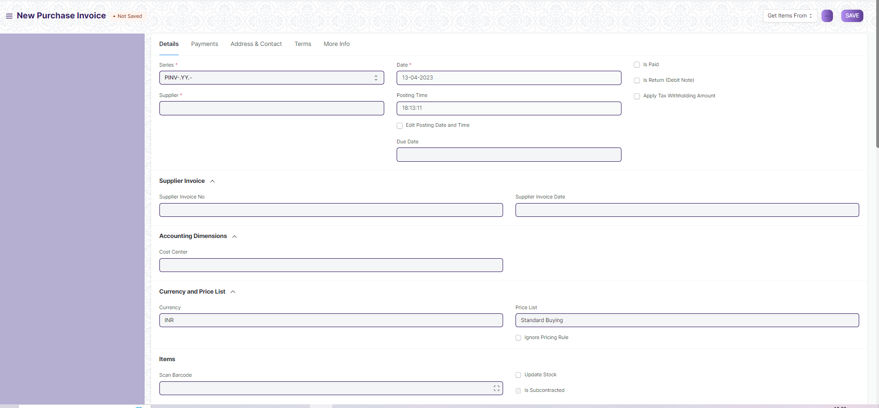

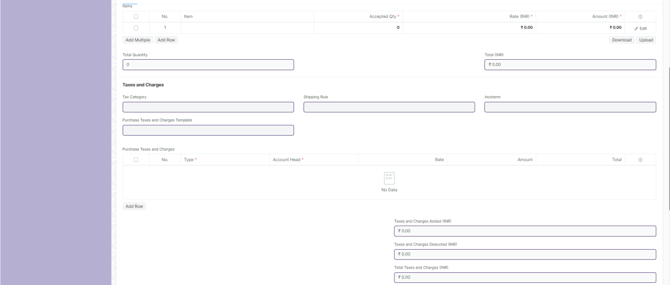

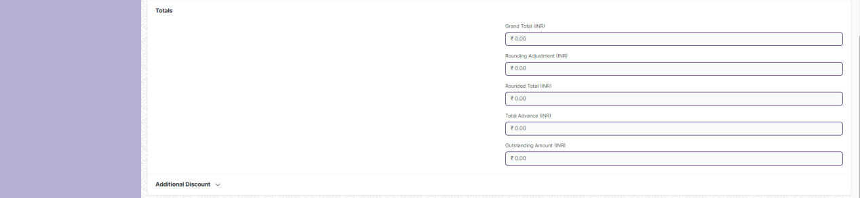

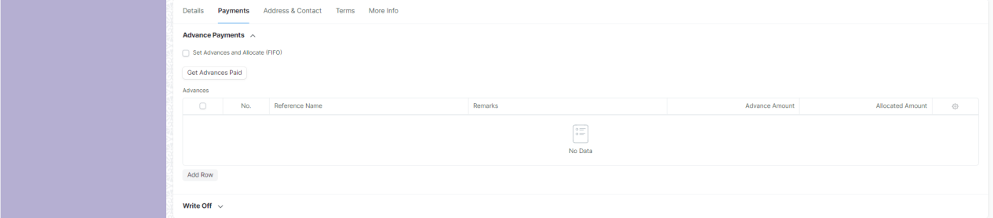

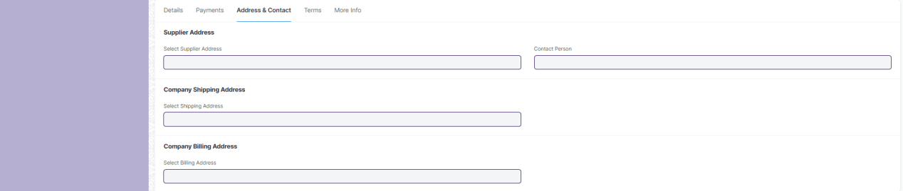

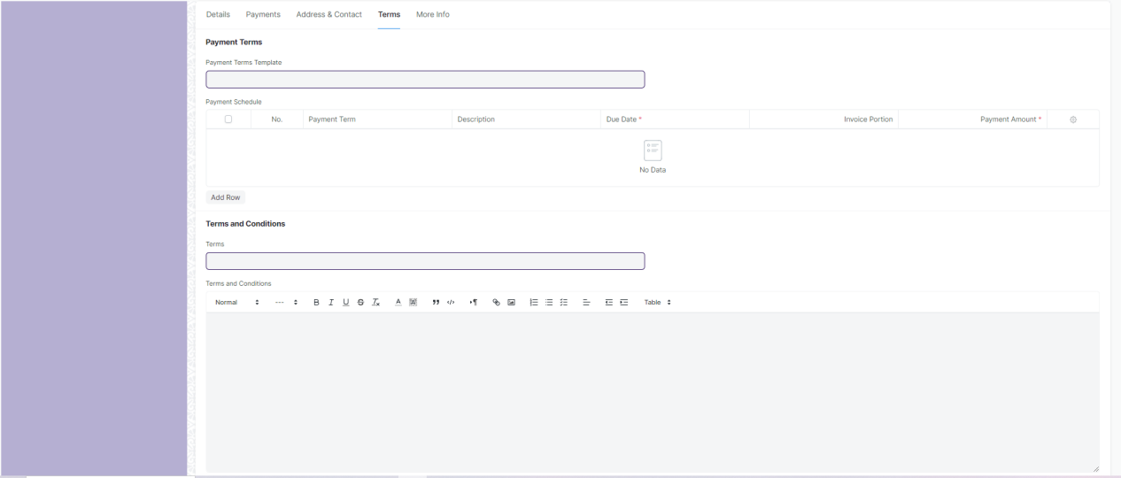

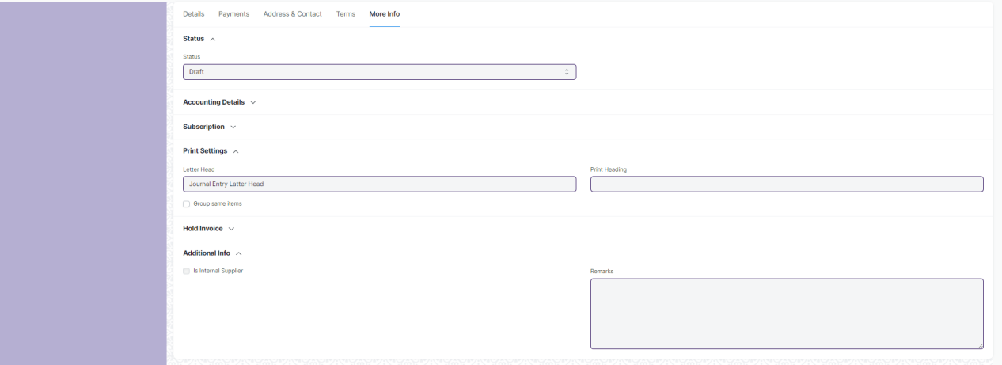

Fig: Purchase Invoice

**UI Fields**

The “Purchase Invoice” screen shall consist of the following fields:

|  |  |  |  |  |  |
| --- | --- | --- | --- | --- | --- |
| **Field Label** | **Field Type** | **Validation/Action** | **Mandatory** | **Remarks** | **R/N/D** |
| **Details (Tab Break)** | | | | | |
| Series | Dropdown | * PINV-.YY.- * PRET-.YY.- * ACC-PINV-.YYYY.- * ACC-PINV-RET-.YYYY.-   (“PINV-.YY.-” are default value but user will select any one) | Yes |  |  |
| Supplier | Link | Value will fetched from Supplier and user will select any one | Yes |  |  |
| Supplier Name | Text List (Read Only) | Value will auto fetch when Supplier field value given |  |  |  |
| Tax Id | Read Only | Value will auto fetch when Supplier field value given |  |  |  |
| Company | Link | Value will fetched from Company |  |  |  |
| Date | Date Picker | Value will auto fetch but user can able to edit If Checked “Edit Posting Date and Time” field | Yes |  |  |
| Posting Time | Time | Value will auto fetch but user can able to edit If Checked “Edit Posting Date and Time” field |  |  |  |
| Edit Posting Date and Time | Checkbox | If Checked “Edit Posting Date and Time” field then user can edit Date and Posting Time |  |  |  |
| Due Date | Date Picker | User will give date |  |  |  |
| Is Paid | Checkbox | If checked then Payment is done and Due Date field will be hide |  |  |  |
| Is Return (Debit Note) | Checkbox | If Checked, return will applied against purchase Invoice |  |  |  |
| Return Against Purchase Invoice | Link (Read Only) | Field will visible when “Is Return” is checked and Value will fetched from Purchase Invoice. User will select any one |  |  |  |
| Apply Tax Withholding Amount | Checkbox | If Checked, it applied for Tax Withholding Category |  |  |  |
| Tax Withholding Category | Link | Value will fetched from “Tax Withholding Category” and user will select any one |  |  |  |
| Supplier Invoice No | Text Field | User will give input |  |  |  |
| Supplier Invoice Date | Date Picker | User will give date |  |  |  |
| Cost Center | Link | Value will fetched from “Cost Center” and user will select any one |  |  |  |
| Currency | Link | Currency will auto fetch but user can able to change |  |  |  |
| Exchange Rate | Number | When you select other Country currency then this field will fetch and value will given but user can able to change |  |  |  |
| Price List | Link | Value will fetch from Price list |  |  |  |
| Price List Currency | Link (Read Only) | Value will fetch from currency when Price List field value are given and Price List form value are given for other country |  |  |  |
| Price List Exchange Rate | Number | Field are visible when Price List field value are given and Price List form value are given for other country and User can able to change the value |  |  |  |
| Ignore Pricing Rule | Checkbox | If checked then it ignore pricing rule |  |  |  |
| Scan Barcode | Number | User will give input. By Reader or camera user will also give input |  |  |  |
| Update Stock | Checkbox | If checked, stock will update |  |  |  |
| Set Accepted Warehouse | Link | This field will visible if checked update stock. Value will fetched from Warehouse and user will select any one |  |  |  |
| Set From Warehouse | Link | If Supplier will be internal then this filed will be visible and value will fetched from Warehouse and user will select any one |  |  |  |
| Is Subcontracted | Checkbox (Read Only) | If Checked, Subcontracted is applied |  |  |  |
| Rejected Warehouse | Link | Value will fetched from Warehouse and user will select any one |  |  |  |
| Supplier Warehouse | Link | If Checked “Is Subcontracted” then this field visible and value will fetched from Warehouse and user will select any one |  |  |  |
| **Items** | **Table** |  | Yes | This table is describe below |  |
| Total Quantity | Number (Read Only) | Value will fetch according to Item child table field value. |  |  |  |
| Total Net Weight | Number (Read Only) | Value will fetch according to Item child table field value. |  |  |  |
| Total (Company Currency) | Currency (Read Only) | Value will fetch according to Item child table field value. |  |  |  |
| Net Total (Company Currency) | Currency (Read Only) | Value will fetch according to Item child table field value. |  |  |  |
| Total | Currency (Read Only) | Value will fetch according to Item child table field value. |  |  |  |
| Net Total | Currency (Read Only) | Value will fetch according to Item child table field value. |  |  |  |
| Tax Category | Link | Value will fetched from Tax Category and user will select any one |  |  |  |
| Purchase Taxes and Charges Template | Link | Value will fetched from Purchase Taxes and Charges Template and user will select any one |  |  |  |
| Shipping Rule | Link | Value will fetched from Shipping Rule and user will select any one |  |  |  |
| Incoterm | Link | Value will fetched from Incoterm and user will select any one |  |  |  |
| Named Place | Text Field | Field will visible when Incoterm value given. User will give input |  |  |  |
| **Purchase Taxes and Charges** | **Table** | Value will fetch according to “Purchase Taxes and Charges Template” field value |  | This table is describe below for manual process |  |
| Taxes and Charges Added (Company Currency) | Currency (Read Only) | Value will fetch according to “Purchase Taxes and Charges”child table field value. |  |  |  |
| Taxes and Charges Deducted (Company Currency) | Currency (Read Only) | Value will fetch according to “Purchase Taxes and Charges”child table field value. |  |  |  |
| Total Taxes and Charges (Company Currency) | Currency (Read Only) | Value will fetch according to “Purchase Taxes and Charges”child table field value. |  |  |  |
| Taxes and Charges Added | Currency (Read Only) | Value will fetch according to “Purchase Taxes and Charges”child table field value. |  |  |  |
| Taxes and Charges Deducted | Currency (Read Only) | Value will fetch according to “Purchase Taxes and Charges”child table field value. |  |  |  |
| Total Taxes and Charges | Currency (Read Only) | Value will fetch according to “Purchase Taxes and Charges”child table field value. |  |  |  |
| Grand Total (Company Currency) | Currency (Read Only) | Value will fetch automatically according to other field |  |  |  |
| Rounding Adjustment (Company Currency) | Currency (Read Only) | Value will fetch automatically according to other field |  |  |  |
| Rounded Total (Company Currency) | Currency (Read Only) | Value will fetch automatically according to other field |  |  |  |
| In Words (Company Currency) | Text Field (Read Only) | Value will fetch automatically according to Grand Total (Company Currency) field |  |  |  |
| Grand Total | Currency (Read Only) | Value will fetch automatically according to other field |  |  |  |
| Rounding Adjustment | Currency (Read Only) | Value will fetch automatically according to other field |  |  |  |
| Rounded Total | Currency (Read Only) | Value will fetch automatically according to other field |  |  |  |
| In Words | Text Field (Read Only) | Value will fetch automatically according to Grand Total field |  |  |  |
| Total Advance | Currency (Read Only) | Value will auto fetch when payment is done in advance |  |  |  |
| Outstanding Amount | Currency (Read Only) | Value will auto fetch when payment is pending |  |  |  |
| Disable Rounded Total | Checkbox | If checked Rounding Adjustment is not applicable |  |  |  |
| Apply Additional Discount On | Dropdown | * Grand Total * Net Total   (Grand Total are default value but user can able to change into Net Total) |  |  |  |
| Additional Discount Amount (Company Currency) | Currency (Read Only) | Value will auto fetch according to the discount |  |  |  |
| Additional Discount Percentage | Number | User will give Input |  |  |  |
| Additional Discount Amount | Currency | User will give Input |  |  |  |
| **Tax Withheld Vouchers** | **Table (Read Only)** | Value fetched automatically based on the tax templates and tax rules that have been set up in the system. |  | This table is describe below |  |
| Taxes and Charges Calculation | Long Text (Read Only) | After all tax calculation value will auto fetch |  |  |  |
| **Pricing Rule Detail** | **Table** **(Read Only)** | Auto fetch according to Pricing rule |  | This table is describe below |  |
| **Supplied Items** | **Table** | Auto fetch according to Supplied Items |  | This table is describe below |  |
| **Payments (Tab Break)** | | | | | |
| Mode of Payment | Link | If amount is paid value will fetch |  |  |  |
| Paid Amount (Company Currency) | Currency (Read Only) | If amount is paid value will fetch |  |  |  |
| Clearance Date | Date Picker (Read Only) | If amount is paid value will fetch |  |  |  |
| Cash/Bank Account | Link | If amount is paid value will fetch |  |  |  |
| Paid Amount | Currency | If amount is paid value will fetch |  |  |  |
| Set Advances and Allocate (FIFO) | Checkbox | If checked, then it applied for FIFO and “Get Advances Paid” Button will hide |  |  |  |
| Get Advances Paid | Button | When user will click button then value will fetch on Advance Table |  |  |  |
| **Advances** | **Table** |  |  | This table is describe below |  |
| Write Off Amount | Currency | User will give input |  |  |  |
| Write Off Amount (Company Currency) | Currency (Read Only) | Value will auto fetch from write off amount |  |  |  |
| Write Off Account | Link | Field will visble when user give value on Write Off Amount and value will fetch from Account and user will select one |  |  |  |
| Write Off Cost Center | Link | Field will visble when user give value on Write Off Amount and value will fetch from Cost Center and user will select one |  |  |  |
| **Address & Contact (Tab Break)** | | | | | |
| Select Supplier Address | Link | Value will fetched from Address and user will select any one |  |  |  |
| Address | Small Text (Read Only) | Value will fetch when Supplier Address field value given |  |  |  |
| Supplier GSTIN | Text Field (Read Only) | After selecting the Supplier, this value will be auto fetch |  |  |  |
| GST Category | Text Field (Read Only) | After selecting the Supplier, this value will be auto fetch |  |  |  |
| Contact Person | Link | Value will fetched from Contact and user will select any one |  |  |  |
| Contact | Small Text (Read Only) | Value will fetch when Contact Person field value given |  |  |  |
| Mobile No | Small Text (Read Only) | Value will fetch when Contact Person field value given |  |  |  |
| Contact Email | Small Text (Read Only) | Value will fetch when Contact Person field value given |  |  |  |
| Select Shipping Address | Link | After selecting the Supplier, this value will be auto fetch but user can able to edit |  |  |  |
| Shipping Address | Small Text (Read Only) | After selecting the Supplier, this value will be auto fetch |  |  |  |
| Select Billing Address | Link | After selecting the Supplier, this value will be auto fetch but user can able to edit |  |  |  |
| Billing Address | Small Text (Read Only) | After selecting the Supplier, this value will be auto fetch |  |  |  |
| Company GSTIN | Text Field (Read Only) | After selecting the Supplier, this value will be auto fetch |  |  |  |
| Place of Supply | Text Field (Read Only) | After selecting the Supplier, this value will be auto fetch |  |  |  |
| **Terms (Tab Break)** | | | | | |
| Payment Terms Template | Link | After selecting the Supplier, this value will be auto fetch but user can able to edit |  |  |  |
| **Payment Schedule** | **Table** | Value will fetch according to “Payment Terms Template” field value |  | This table is describe below for manual process |  |
| Terms | Link | Value will fetched from “Terms and Conditions” and user will select any one |  |  |  |
| Terms and Conditions | Text Editor | Value will fetch when “Terms and Conditions” field value given and User can able to edit |  |  |  |
| **More Info (Tab Break)** | | | | | |
| Status | Dropdown | * Draft * Return * Debit Note Issued * Submitted * Paid * Partly Paid * Unpaid * Overdue * Cancelled * Internal Transfer   (It will auto fetch according to the form condition) |  |  |  |
| Credit To | Link | Value will fetched from Account and user will select any one | Yes |  |  |
| Is Opening Entry | Dropdown | * Yes * No   (User will select one) |  |  |  |
| Unrealized Profit / Loss Account | Link | User will give input if supplier is internal |  |  |  |
| Auto Repeat | Link (Read Only) | Auto Repeat the Purchase Invoice at specified intervals.(After submitting the form it will visible) |  |  |  |
| Update Auto Repeat Reference | Button | When value are present in Auto Repeat field then this button are visible. User will click and update Auto Repeat |  |  |  |
| From Date | Date Picker | User will give date |  |  |  |
| To Date | Date Picker | User will give date |  |  |  |
| Letter Head | Link | Value will fetched from Letter Head and user will select any one |  |  |  |
| Group same items | Checkbox | If checked then grouped same item |  |  |  |
| Print Heading | Link | Value will fetched from Print Heading and user will select any one |  |  |  |
| Print Language | Text Field (Read Only) | Value will auto fetch when give supplier name In supplier field |  |  |  |
| Hold Invoice | Checkbox | If Checked, Invoice will be on hold. |  |  |  |
| Release Date | Date Picker | When Hold Invoice is checked then this field will visible and user will give date |  |  |  |
| Reason For Putting On Hold | Small Text | When Hold Invoice is checked then this field will visible and user will give input |  |  |  |
| Is Internal Supplier | Checkbox (Read Only) | If checked then supplier will be internal |  |  |  |
| Represents Company | Link | Value will auto fetch from Company |  |  |  |
| Inter Company Invoice Reference | Link (Read Only) | Value will auto fetch from Company |  |  |  |
| Remarks | Small Text | User will give input |  |  |  |
| Create | Button | Purchase receipt: On click of this button you will be able to create Purchase receipt |  |  |  |
| Return/ Debit note: On click of this button you can create return or debit note |  |  |  |
| Subscription: Subscription: On click of this button you can create subscription for the Purchase receipt |  |  |  |
| View | Button | Accounting Ledger: On click of this button you will be able to see Accounting Ledger |  |  |  |
| **Items (Child Table)** | | | | | |
| **Field Label** | **Field Type** | **Validation/Action** | **Mandatory** | **Remarks** | **R/N/D** |
| Item | Link | Value will fetched from Item and user will select any one |  |  |  |
| Product Bundle | Link (Read Only) | Value will auto fetch from Product Bundle according to the Item |  |  |  |
| Item Name | Text Field | Value will fetch when user will give Item Code field input but user can edit | Yes |  |  |
| Description | Text Editor | Value will fetch when user will give Item Code field input but user can edit |  |  |  |
| HSN/SAC | Text Field | Value will fetch when user will give Item Code field input but user can edit |  |  |  |
| Is Nil Rated or Exempted | Check | Tax is not applicable if checked |  | Tax is applicable for all item | D |
| Is Non GST | Checkbox | If checked, For an item that is not covered under GST |  |  |  |
| Item Group | Link (Read Only) | Value will fetch when user will give Item Code field input |  |  |  |
| Image View | Image | Image will fetch when user will give Item Code field input |  |  |  |
| Received Qty | Number (Read Only) | Value will fetch when user will give Item Code field input |  |  |  |
| Accepted Qty | Number | Value will fetch when user will give Item Code field input | Yes |  |  |
| Rejected Qty | Number | Value will fetch when user will give Item Code field input |  |  |  |
| UOM | Link | Value will fetch when user will give Item Code field input but user can edit | Yes |  |  |
| UOM Conversion Factor | Number (Read Only) | Value will fetch when user will give UOM field input but user can edit | Yes |  |  |
| Stock UOM | Link (Read Only) | Value will fetch when user will give UOM field input |  |  |  |
| Accepted Qty in Stock UOM | Number (Read Only) | Value will fetch when user will give UOM field input | Yes |  |  |
| Price List Rate | Currency (Read Only) | Value will fetch when user will give Item Code field input but user can edit |  |  |  |
| Price List Rate (Company Currency) | Currency (Read Only) | Value will fetch when user will give Item Code field input |  |  |  |
| Margin Type | Dropdown | * Percentage * Amount   (User will select one) |  |  |  |
| Margin Rate or Amount | Number | Field will visible when user will give input to Margin Type field |  |  |  |
| Rate With Margin | Currency (Read Only) | Field will visible when user will give input to Margin Rate or Amount field |  |  |  |
| Discount on Price List Rate (%) | Percent | User will give Input |  |  |  |
| Discount Amount | Currency | User will give Input |  |  |  |
| Rate With Margin (Company Currency) | Currency (Read Only) | Field will visible when user will give input to Margin Type field |  |  |  |
| Rate | Currency | Value will fetch when user will give Item Code field input but user can edit | Yes |  |  |
| Amount | Currency (Read Only) | Value will fetch when user will give Item Code field input | Yes |  |  |
| Item Tax Template | Link | Value will fetched from Item Tax Template and user will select any one |  |  |  |
| Rate (Company Currency) | Currency (Read Only) | Value will fetch when user will give Item Tax Template field input | Yes |  |  |
| Amount (Company Currency) | Currency (Read Only) | Value will fetch when user will give Item Tax Template field input | Yes |  |  |
| Rate of Stock UOM | Currency (Read Only) | Value will fetch when user will give Item Tax Template field input |  |  |  |
| Is Free Item | Checkbox (Read Only) | If Checked, Item will be free of cost |  |  |  |
| Apply TDS | Checkbox | If Checked, TDS will applied for that item |  |  |  |
| Net Rate | Currency (Read Only) | Value will fetch when user will give Item Code field input |  |  |  |
| Net Amount | Currency (Read Only) | Value will fetch when user will give Item Code field input |  |  |  |
| Net Rate (Company Currency) | Currency (Read Only) | Value will fetch when user will give Item Code field input |  |  |  |
| Net Amount (Company Currency) | Currency (Read Only) | Value will fetch when user will give Item Code field input |  |  |  |
| Landed Cost Voucher Amount | Currency (Read Only) | Value will fetch when user will give Item Code field input |  |  |  |
| Accepted Warehouse | Link | Value will fetched from Warehouse and user will select any one |  |  |  |
| Quality Inspection | Link | Value will fetched from Quality Inspection and user will select any one |  |  |  |
| Serial No | Text | User will give input |  |  |  |
| Rejected Warehouse | Link | Value will fetched from Warehouse and user will select any one |  |  |  |
| Batch No | Link | Value will fetch when user will give Item Code field input But user can able to change |  |  |  |
| Rejected Serial No | Text | User will give input |  |  |  |
| Manufacturer | Link |  |  | It is for a Manufacture module | D |
| Manufacturer Part Number | Text Field |  |  | It is for a Manufacture module | D |
| Expense Head | Link | Value will fetched from Account and user will select any one |  |  |  |
| Asset Location | Link | Value will fetched from Location and user will select any one |  |  |  |
| Asset Category | Link (Read Only) | Value will fetch when user will give Item Code field input |  |  |  |
| Deferred Expense Account | Link | This field will visible when Enable Deferred Expense Checked, User will give input |  |  |  |
| Service Stop Date | Date Picker | This field will visible when Enable Deferred Expense Checked, User will give date |  |  |  |
| Enable Deferred Expense | Checkbox | If Checked, then applied for deferred expense |  |  |  |
| Service Start Date | Date Picker | This field will visible when Enable Deferred Expense Checked, User will give date |  |  |  |
| Service End Date | Date Picker | This field will visible when Enable Deferred Expense Checked, User will give date |  |  |  |
| Allow Zero Valuation Rate | Checkbox | If Checked, valuation will be zero |  |  |  |
| BOM | Link (Read Only) |  |  | It is for a Manufacture module | D |
| Include Exploded Items | Checkbox (Read Only) | Value will fetch when user will give Item Code field input |  |  |  |
| Purchase Invoice Item | Text Field (Read Only) | Value will fetch when user will give Item Code field input |  |  |  |
| Purchase Order | Link (Read Only) | Value will fetch when user will give Item Code field input |  |  |  |
| Purchase Receipt | Link (Read Only) | Value will fetch when user will give Item Code field input |  |  |  |
| Sales Invoice Item | Text Field (Read Only) | Value will fetch when user will give Item Code field input |  |  |  |
| Weight Per Unit | Number | User will give Input |  |  |  |
| Total Weight | Number (Read Only) | Value will fetch when user will give Item Code field input |  |  |  |
| Weight UOM | Link | Value will fetched from Account and user will select any one |  |  |  |
| Address | Link | Value will fetched from Address and user will select any one |  |  |  |
| Article | Link | Value will fetched from Article and user will select any one |  |  |  |
| Project | Link | Value will fetched from Project and user will select any one |  |  |  |
| About Us Team Member | Link |  |  | It’s not link with any form, Value will not fetch from anywhere | D |
| Cost Center | Link | Value will fetched from Cost Center and user will select any one |  |  |  |
| Page Break | Checkbox | If checked then Page Break will create a page break just before this item when printing |  |  |  |
| **Purchase Taxes and Charges (Child Table)** | | | | | |
| **Field Label** | **Field Type** | **Validation/Action** | **Mandatory** | **Remarks** | **R/N/D** |
| Consider Tax or Charge for | Dropdown | * Valuation and Total * Valuation * Total   (“Total” are default value but user can able to change into “Valuation and Total”  or “Valuation”) | Yes |  |  |
| Add or Deduct | Dropdown | * Add * Deduct   (“Add” are default value but user can able to change into “Deduct”) | Yes |  |  |
| Type | Dropdown | * Actual * On Net Total * On Previous Row Amount * On Previous Row Total * On Item Quantity   (“On Net Total”are default value but user can able to change into other) | Yes |  |  |
| Reference Row # | Text Field | If tax is based on "Previous Row Total" User can select the row number which will be taken as a base for this calculation |  |  |  |
| Is this Tax included in Basic Rate? | Checkbox | If checked, the tax amount will be considered as already included in the Print Rate / Print Amount |  |  |  |
| Considered In Paid Amount | Checkbox | If checked, considered in paid amount |  |  |  |
| Account Head | Link | Value will fetched from Account and user will select any one | Yes |  |  |
| Description | Small Text | Value will auto fetch when we give value in Account Head field but user can edit | Yes |  |  |
| Rate | Number | Value will auto fetch when we give value in Account Head field but user can edit |  |  |  |
| Address | Link | Value will fetched from Address and user will select any one |  |  |  |
| Article | Link | Value will fetched from Article and user will select any one |  |  |  |
| Cost Center | Link | Value will auto fetch when we give value in Account Head field but user can edit |  |  |  |
| About Us Team Member | Link |  |  | It’s not link with any form,  Value will not fetch from anywhere | D |
| Account Currency | Link (Read Only) | Value will auto fetch when we give value in Account Head field |  |  |  |
| Amount | Currency | Value will auto fetch when we give value in Account Head field but user can edit |  |  |  |
| Tax Amount After Discount Amount | Currency (Read Only) | Value will auto fetch when we give value in Account Head field but user can edit |  |  |  |
| Total | Currency (Read Only) | Value will auto fetch when we give value in Account Head field but user can edit |  |  |  |
| Amount (Company Currency) | Currency (Read Only) | Value will auto fetch when we give value in Account Head field but user can edit |  |  |  |
| Tax Amount After Discount Amount | Currency (Read Only) | Value will auto fetch when we give value in Account Head field but user can edit |  |  |  |
| **Tax Withheld Vouchers (Child Table)** | | | | | |
| **Field Label** | **Field Type** | **Validation/Action** | **Mandatory** | **Remarks** | **R/N/D** |
| Voucher Type | Link | Value fetched automatically based on the tax templates and tax rules that have been set up in the system. |  |  |  |
| Voucher Name | Link | Value fetched automatically based on the tax templates and tax rules that have been set up in the system. |  |  |  |
| Taxable Amount | Currency | Value fetched automatically based on the tax templates and tax rules that have been set up in the system. |  |  |  |
| **Pricing Rule Detail (Child Table)** | | | | | |
| **Field Label** | **Field Type** | **Validation/Action** | **Mandatory** | **Remarks** | **R/N/D** |
| Pricing Rule | Link | Value will auto fetch from Pricing Rule if it is applicable for account |  |  |  |
| Item Code | Text Field | Value will auto fetch according Pricing Rule |  |  |  |
| Rule Applied | Checkbox | If Checked, rule will applied for account pricing |  |  |  |
| **Supplied Items (Child Table)** | | | | | |
| **Field Label** | **Field Type** | **Validation/Action** | **Mandatory** | **Remarks** | **R/N/D** |
| Item Code | Link | Value auto fetch When transfer Material to Supplier |  |  |  |
| Raw Material Item Code | Link | Value auto fetch When transfer Material to Supplier |  |  |  |
| Stock Uom | Link | Value auto fetch When transfer Material to Supplier |  |  |  |
| Reserve Warehouse | Link | Value auto fetch When transfer Material to Supplier |  |  |  |
| BOM Detail No | Text Field |  |  | It is for a Manufacture module | D |
| Reference Name | Text Field | Value auto fetch When transfer Material to Supplier |  |  |  |
| Rate | Currency | Value auto fetch When transfer Material to Supplier |  |  |  |
| Amount | Currency | Value auto fetch When transfer Material to Supplier |  |  |  |
| Required Qty | Number | Value auto fetch When transfer Material to Supplier |  |  |  |
| Supplied Qty | Number | Value auto fetch When transfer Material to Supplier |  |  |  |
| Consumed Qty | Number | Value auto fetch When transfer Material to Supplier |  |  |  |
| Returned Qty | Number | Value auto fetch When transfer Material to Supplier |  |  |  |
| **Advances (Child Table)** | | | | | |
| **Field Label** | **Field Type** | **Validation/Action** | **Mandatory** | **Remarks** | **R/N/D** |
| Reference Type | Link (Read Only) | When user click “Get Advances Paid” button then value will fetch |  |  |  |
| Reference Name | Link (Read Only) | When user click “Get Advances Paid” button then value will fetch |  |  |  |
| Remarks | Text (Read Only) | When user will click “Get Advances Paid” button then value will fetch |  |  |  |
| Advance Amount | Currency (Read Only) | When user will click “Get Advances Paid” button then value will fetch |  |  |  |
| Allocated Amount | Currency | When user will click “Get Advances Paid” button then value will fetch but user can edit |  |  |  |
| Exchange Gain/Loss | Currency (Read Only) | When user will click “Get Advances Paid” button then value will fetch |  |  |  |
| Reference Exchange Rate | Number (Read Only) | When user will click “Get Advances Paid” button then value will fetch |  |  |  |
| **Payment Schedule (Child Table)** | | | | | |
| **Field Label** | **Field Type** | **Validation/Action** | **Mandatory** | **Remarks** | **R/N/D** |
| Payment Term | Link | Value will fetched from Payment Term and user will select any one |  |  |  |
| Description | Small Text | Value will give input |  |  |  |
| Due Date | Date Picker | Value will auto fetch when user give input in Payment Term field but user can able to edit | Yes |  |  |
| Mode of Payment | Link | Value will auto fetch when user give input in Payment Term field but user can able to edit |  |  |  |
| Invoice Portion | Percent | Value will auto fetch when user give input in Payment Term field but user can able to edit |  |  |  |
| Discount Type | Select | * Percentage * Amount   (Percentage Is default value but user can change into Amount) |  |  |  |
| Discount Date | Date Picker | Value will auto fetch when user give input in Discount field but user can able to edit |  |  |  |
| Discount | Number | User will give Input |  |  |  |
| Payment Amount | Currency | Value will auto fetch when user give input in Payment Term field but user can able to edit | Yes |  |  |
| Outstanding | Currency (Read Only) | Value will auto fetch when user give input in Payment Term field |  |  |  |
| Paid Amount | Currency | Value will auto fetch when user give input in Payment Term field but user can able to edit |  |  |  |
| Discounted Amount | Currency (Read Only) | Value will auto fetch according to the discount |  |  |  |
| Payment Amount (Company Currency) | Currency | Value will auto fetch when user give input in Payment Term field but user can able to edit |  |  |  |

**Users: Roles and Permissions**

The following table describes the users and their roles and permissions for the screens :

|  |  |  |  |  |  |  |  |  |  |
| --- | --- | --- | --- | --- | --- | --- | --- | --- | --- |
| **ID** | **Role** | **Select** | **Read** | **Write** | **Create** | **Delete** | **Submit** | **Cancel** | **Amend** |
|  | GM-Procurement & Contract Management | Yes | Yes | Yes | Yes | Yes | Yes | Yes | Yes |
|  | Purchase User | Yes | Yes | Yes | Yes | Yes | Yes | Yes | Yes |

## Stocks

### 3.1 Stock Entry

**General Description**

The Following table describe overall information about this screen:

|  |  |
| --- | --- |
| **Description :** | A Stock Entry lets you record Item movement between Warehouses. |
| **Navigation :** | Home > Material Management > Stock Transaction and report > Stock Entry |
| **Pre-requisites :** | 1. Item 2. Warehouse |

**Stock Entry Screenshot**

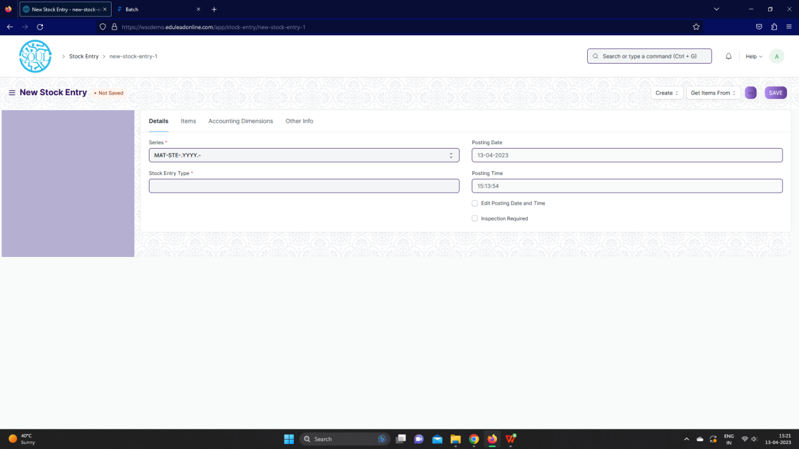

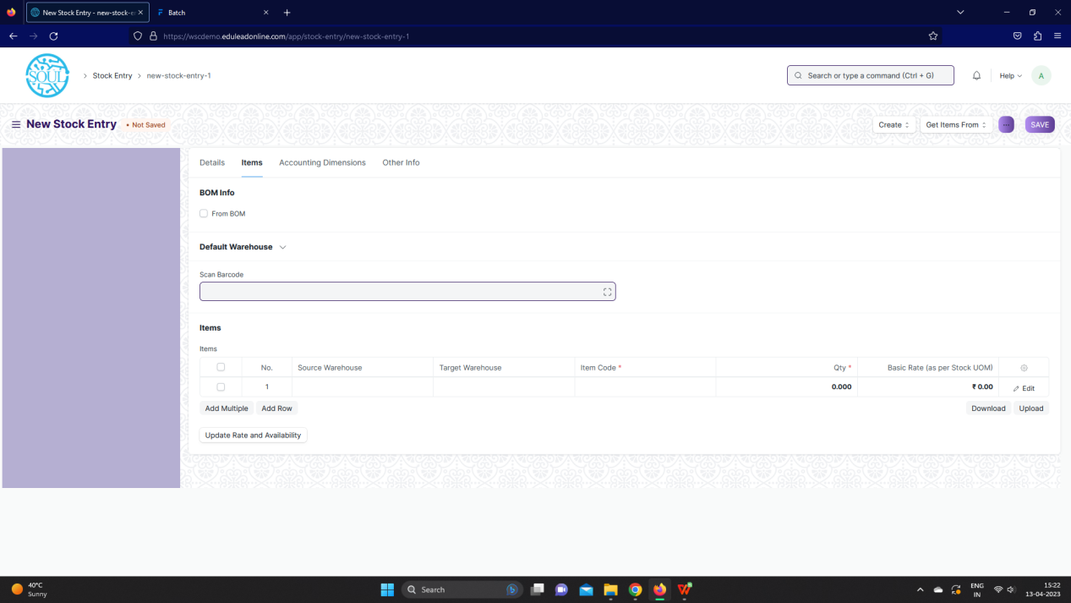

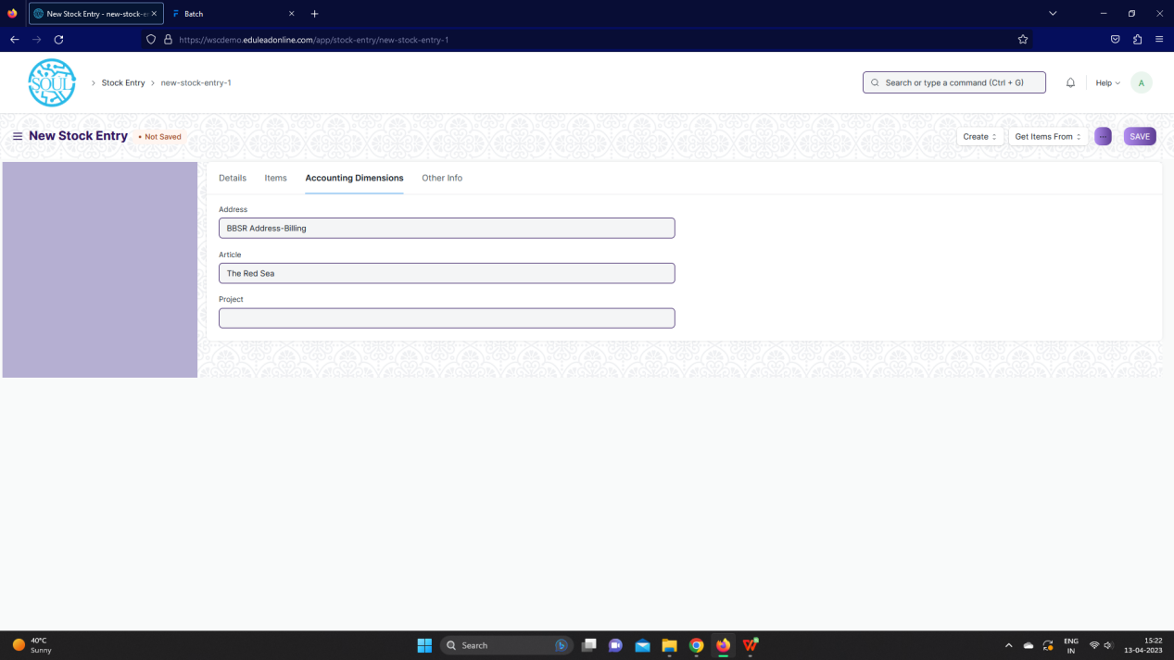

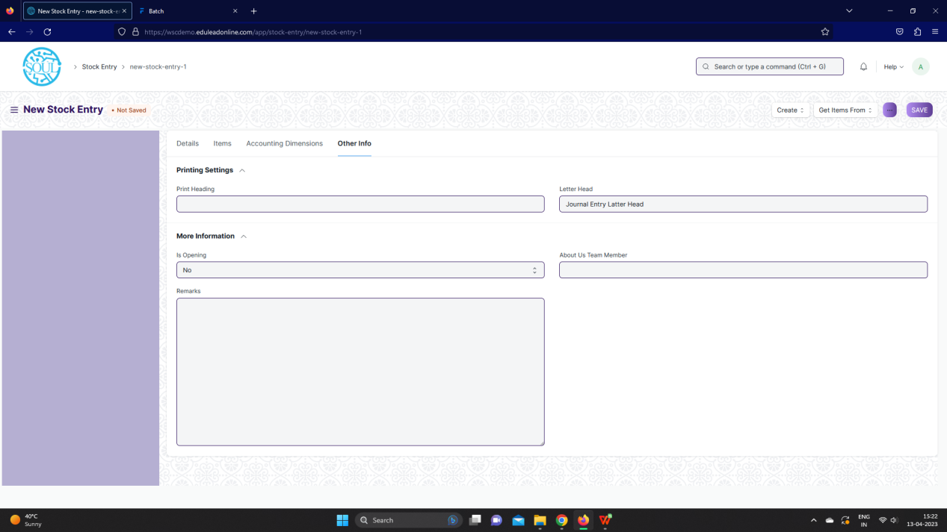

Fig: Stock Entry Screen

**UI Fields**

The “Stock Entry” screen shall consist of the following fields:

|  |  |  |  |  |  |  |  |  |  |  |  |  |
| --- | --- | --- | --- | --- | --- | --- | --- | --- | --- | --- | --- | --- |
| **Field Label** | **Field Type** | | | **Validation/ Action** | **Mandatory** | | | | **Remarks** | | | **R/N/D** |
| **Details (Tab Break)** | | | | | | | | | | | | |
| Series | dropdown | | | MAT-STE-.YYYY.- | Yes | | | |  | | |  |
| Stock Entry Type | Link | | | Fetched from Stock Entry Type screen | Yes | | | |  | | |  |
| Purpose | dropdown | | | Material Issue /  Material Receipt /  Material Transfer /  Material Transfer for Manufacture /  Material Consumption for Manufacture /  Manufacture /  Repack /  Send to Subcontractor / |  | | | |  | | |  |
| Posting Date | Date | | | User Input |  | | | |  | | |  |
| Posting Time | Time | | | User Input |  | | | |  | | |  |
| Edit Posting Date and Time | Checkbox | | | User Input |  | | | |  | | |  |
| Inspection Required | Checkbox | | | User Input |  | | | |  | | |  |
| **Items (Tab Break)** | | | | | | | | | | | | |
| From BOM | Checkbox | | | User Input |  | | | | Part of Manufacturing module | | | D |
| Use Multi-Level BOM | Checkbox | | | User Input |  | | | | Part of Manufacturing module | | | D |
| BOM No | Link | | | Fetched from bom\_no screen |  | | | | Part of Manufacturing module | | | D |
| For Quantity | Float | | | User Input |  | | | | Part of Manufacturing module | | | D |
| Get Items | Button | | | On click of this button Items will be populated in child table |  | | | | Part of Manufacturing module | | | D |
| % Process Loss | Percent | | | User Input |  | | | | Part of Manufacturing module | | | D |
| Process Loss Qty | Float | | | User Input |  | | | | Part of Manufacturing module | | | D |
| Default Source Warehouse | Link | | | Fetched from Warehouse screen |  | | | |  | | |  |
| Source Warehouse Address | Link | | | Fetched from Warehouse screen |  | | | |  | | |  |
| Source Warehouse Address | Small Text | | | User Input |  | | | |  | | |  |
| Default Target Warehouse | Link | | | Fetched from Warehouse screen |  | | | |  | | |  |
| Target Warehouse Address | Link | | | Fetched from Warehouse screen |  | | | |  | | |  |
| Target Warehouse Address | Small Text | | | User Input |  | | | |  | | |  |
| Scan Barcode | Text Field | | | User Input |  | | | |  | | |  |
| **Items** | **Table** | | |  | Yes | | | | These table is describe below | | |  |
| Update Rate and Availability | Button | | | On click of this button rates and availability of items will be updates |  | | | |  | | |  |
| Total Outgoing Value (Consumption) | Currency | | | User Input |  | | | |  | | |  |
| Total Incoming Value (Receipt) | Currency | | | User Input |  | | | |  | | |  |
| Total Value Difference (Incoming - Outgoing) | Currency | | | User Input |  | | | |  | | |  |
| **Additional Costs (Tab Break)** | | | | | | | | | | | | |
| **Additional Costs** | **Table** | | |  |  | | | | These table is describe below | | |  |
| Total Additional Costs | Currency | | | User Input |  | | | |  | | |  |
| **Supplier Info (Tab Break)** | | | | | | | | | | | | |
| Supplier | Link | | | Fetched from Supplier screen |  | | | |  | | |  |
| Supplier Name | Text Field | | | User Input |  | | | |  | | |  |
| Supplier Address | Link | | | Fetched from Address screen |  | | | |  | | |  |
| Address | Small Text | | | User Input |  | | | |  | | |  |
| **Accounting Dimensions (Tab Break)** | | | | | | | | | | | | |
| Address | Link | | | Fetched from Address screen |  | | | |  | | |  |
| Article | Link | | | Fetched from Warehouse screen |  | | | | Not required, part of Project module | | | D |
| Project | Link | | | Fetched from Warehouse screen |  | | | | Not required, part of Project module | | | D |
| **Other Info (Tab Break)** | | | | | | | | | | | | |
| Print Heading | Link | | | Fetched from Heading screen |  | | | |  | | |  |
| Letter Head | Link | | | Fetched from Letter Head screen |  | | | |  | | |  |
| Is Opening | dropdown | | | No / Yes |  | | | |  | | |  |
| Remarks | Text | | | User Input |  | | | |  | | |  |
| Per Transferred | Percent | | | User Input |  | | | |  | | |  |
| Total Amount | Currency | | | User Input |  | | | |  | | |  |
| Job Card | Link | | | Fetched from Job card screen |  | | | | Not required, part of manufacturing module | | | D |
| Credit Note | Link | | | Fetched from Credit note screen |  | | | |  | | |  |
| Is Return | Checkbox | | | User Input |  | | | |  | | |  |
| About Us Team Member | Link | | | Fetched from Warehouse screen |  | | | | Not required | | | D |
| View | Button | | | Stock Entry: On click of this button you can view Stock entry |  | | | |  | | |  |
| Ledger Entry: On click of this button you can view Ledger entry |  | | | |  | | |  |
| **Items (Child Table)** | | | | | | | | | | | | | | |
| **Field Label** | | | **Field Type** | **Validation/ Action** | | | **Mandatory** | | **Remarks** | | **R/N/D** | | | |
| Barcode | | | Text Field | User Input | | |  | |  | |  | | | |
| Has Item Scanned | | | Checkbox | User Input | | |  | |  | |  | | | |
| Source Warehouse | | | Link | Fetched from Warehouse screen | | |  | |  | |  | | | |
| Target Warehouse | | | Link | Fetched from warehouse screen | | |  | |  | |  | | | |
| Item Code | | | Link | Fetched from Item screen | | | Yes | |  | |  | | | |
| Item Name | | | Text Field | User Input | | |  | |  | |  | | | |
| Is Finished Item | | | Checkbox | User Input | | |  | |  | |  | | | |
| Is Scrap Item | | | Checkbox | User Input | | |  | |  | |  | | | |
| Quality Inspection | | | Link | Fetched from Quality Inspection screen | | |  | |  | |  | | | |
| Subcontracted Item | | | Link | Fetched from Item screen | | |  | |  | |  | | | |
| Description | | | Text Editor | User Input | | |  | |  | |  | | | |
| Item Group | | | Text Field | User Input | | |  | |  | |  | | | |
| Image | | | Attach | User Input | | |  | |  | |  | | | |
| Image View | | | Image | User Input | | |  | |  | |  | | | |
| Qty | | | Float | User Input | | | Yes | |  | |  | | | |
| Qty as per Stock UOM | | | Float | User Input | | | Yes | |  | |  | | | |
| Retain Sample | | | Checkbox | User Input | | |  | |  | |  | | | |
| UOM | | | Link | Fetched from UOM screen | | | Yes | |  | |  | | | |
| Stock UOM | | | Link | Fetched from UOM screen | | | Yes | |  | |  | | | |
| Conversion Factor | | | Float | User Input | | | Yes | |  | |  | | | |
| Sample Quantity | | | Int | User Input | | |  | |  | |  | | | |
| Basic Rate (as per Stock UOM) | | | Currency | User Input | | |  | |  | |  | | | |
| Additional Cost | | | Currency | User Input | | |  | |  | |  | | | |
| Valuation Rate | | | Currency | User Input | | |  | |  | |  | | | |
| Allow Zero Valuation Rate | | | Checkbox | User Input | | |  | |  | |  | | | |
| Set Basic Rate Manually | | | Checkbox | User Input | | |  | |  | |  | | | |
| Basic Amount | | | Currency | User Input | | |  | |  | |  | | | |
| Amount | | | Currency | User Input | | |  | |  | |  | | | |
| Serial No | | | Small Text | User Input | | |  | |  | |  | | | |
| Batch No | | | Link | Fetched from Batch screen | | |  | |  | |  | | | |
| Difference Account | | | Link | Fetched from Account screen | | |  | |  | |  | | | |
| Address | | | Link | Fetched from Address screen | | |  | | Not required | | D | | | |
| Article | | | Link | Fetched from Article screen | | |  | | Not required | | D | | | |
| Cost Center | | | Link | Fetched from Cost Center screen | | |  | |  | |  | | | |
| Project | | | Link | Fetched from Project screen | | |  | | Not required | | D | | | |
| About Us Team Member | | | Link | Fetched from About Us Team Member screen | | |  | | Not required | | D | | | |
| Actual Qty (at source/target) | | | Float | User Input | | |  | |  | |  | | | |
| Transferred Qty | | | Float | User Input | | |  | |  | |  | | | |
| BOM No | | | Link | Fetched from BOM screen | | |  | |  | |  | | | |
| Allow Alternative Item | | | Checkbox | User Input | | |  | |  | |  | | | |
| Material Request | | | Link | Fetched from Material Request screen | | |  | |  | |  | | | |
| Material Request Item | | | Link | Fetched from Material Request Item screen | | |  | |  | |  | | | |
| Original Item | | | Link | Fetched from Item screen | | |  | |  | |  | | | |
| Against Stock Entry | | | Link | Fetched from Stock Entry screen | | |  | |  | |  | | | |
| Stock Entry Child | | | Text Field | User Input | | |  | |  | |  | | | |
| PO Supplied Item | | | Text Field | User Input | | |  | |  | |  | | | |
| **Additional Cost (Child Table)** | | | | | | | | | | | | | | |
| **Field Label** | | **Field Type** | | **Validation/ Action** | | | **Mandatory** | **Remarks** | | | **R/N/D** | | | |
| Expense Account | | Link | | Fetched from Account screen | | |  |  | | |  | | | |
| Account Currency | | Link | | Fetched from Currency screen | | |  |  | | |  | | | |
| Exchange Rate | | Float | | User Input | | |  |  | | |  | | | |
| Description | | Small Text | | User Input | | | Yes |  | | |  | | | |
| Amount | | Currency | | User Input | | | Yes |  | | |  | | | |
| Amount (Company Currency) | | Currency | | User Input | | |  |  | | |  | | | |

**Users: Roles and Permissions**

The following table describes the users and their roles and permissions for the screens :

|  |  |  |  |  |  |  |  |  |  |
| --- | --- | --- | --- | --- | --- | --- | --- | --- | --- |
| **ID** | **Role** | **Select** | **Read** | **Write** | **Create** | **Delete** | **Submit** | **Cancel** | **Amend** |
|  | GM-Procurement & Contract Management | Yes | Yes | Yes | Yes | Yes | Yes | Yes | Yes |
|  | Purchase Manager | Yes | Yes | Yes | Yes | Yes | Yes | Yes | Yes |

### 3.2 Stock Setting

**General Description**

The Following table describe overall information about this screen:

|  |  |
| --- | --- |
| **Description :** | You can set default settings for your stock related transactions from the Stock Settings |
| **Navigation :** | Home > Material Management > Stock Transaction and report > Stock Setting |
| **Pre-requisites :** | None |

**Stock Setting Screenshot**

**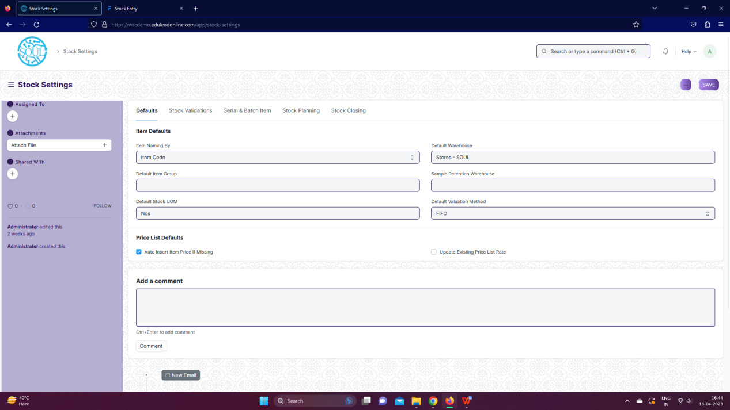**

**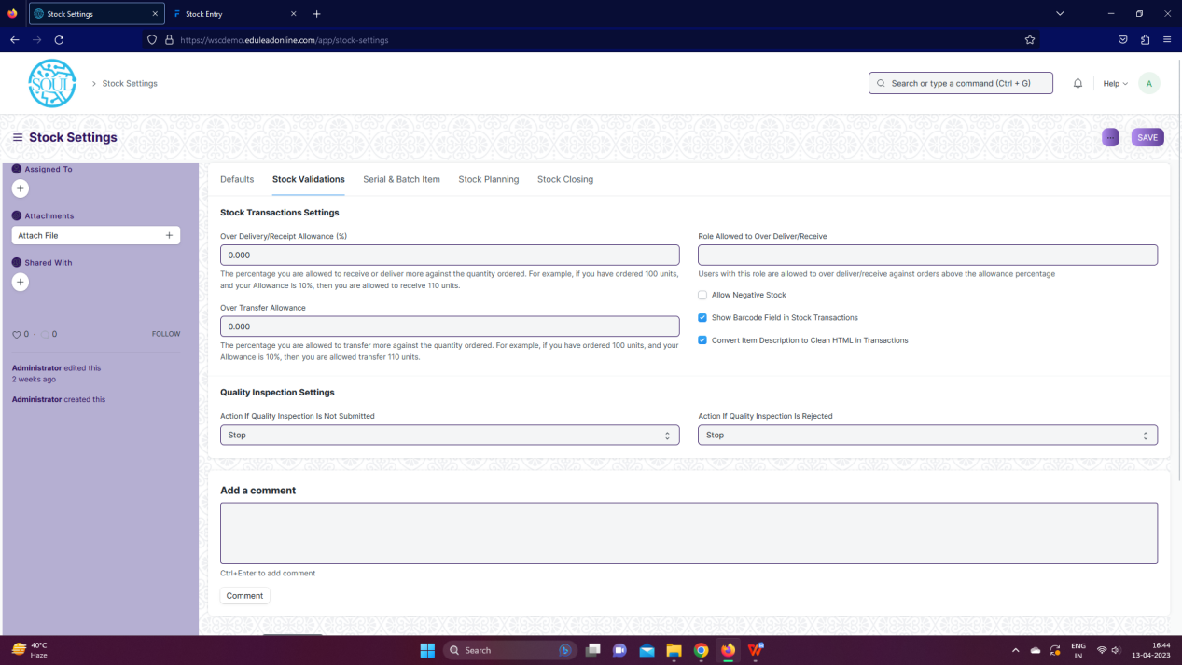**

**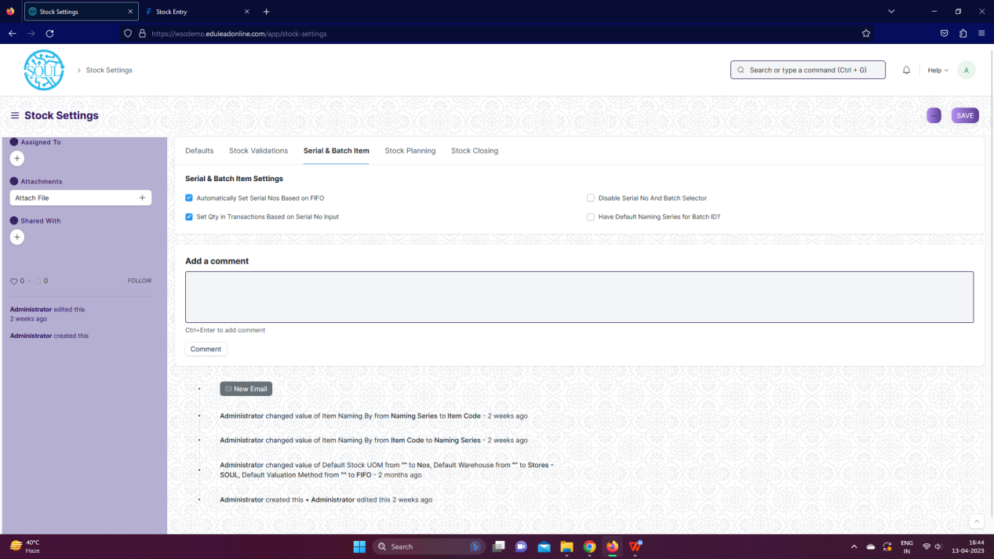**

**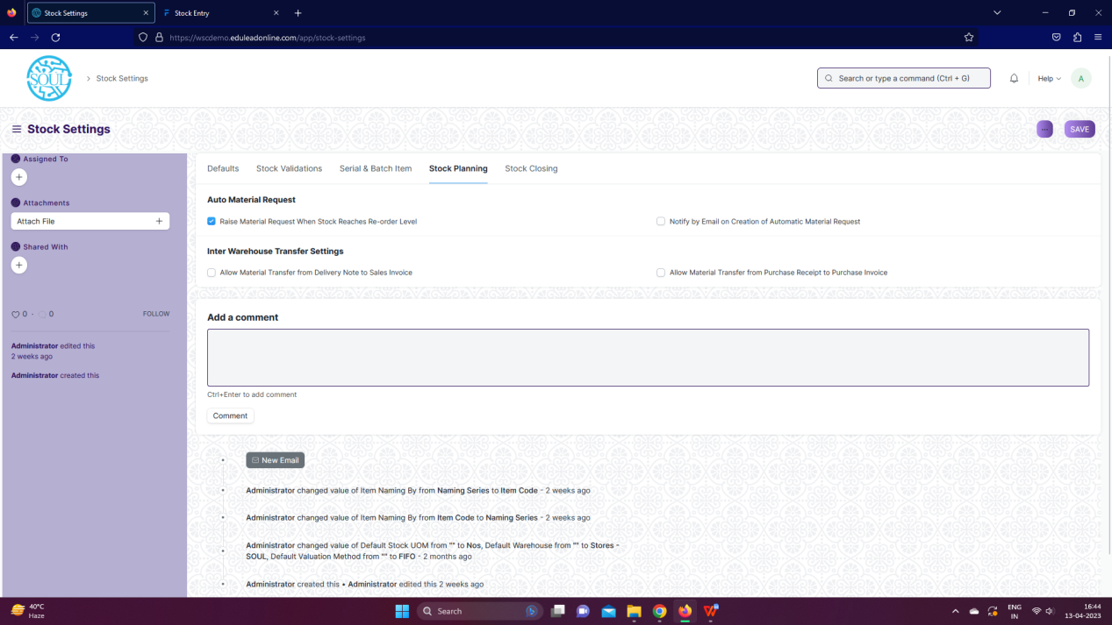**

**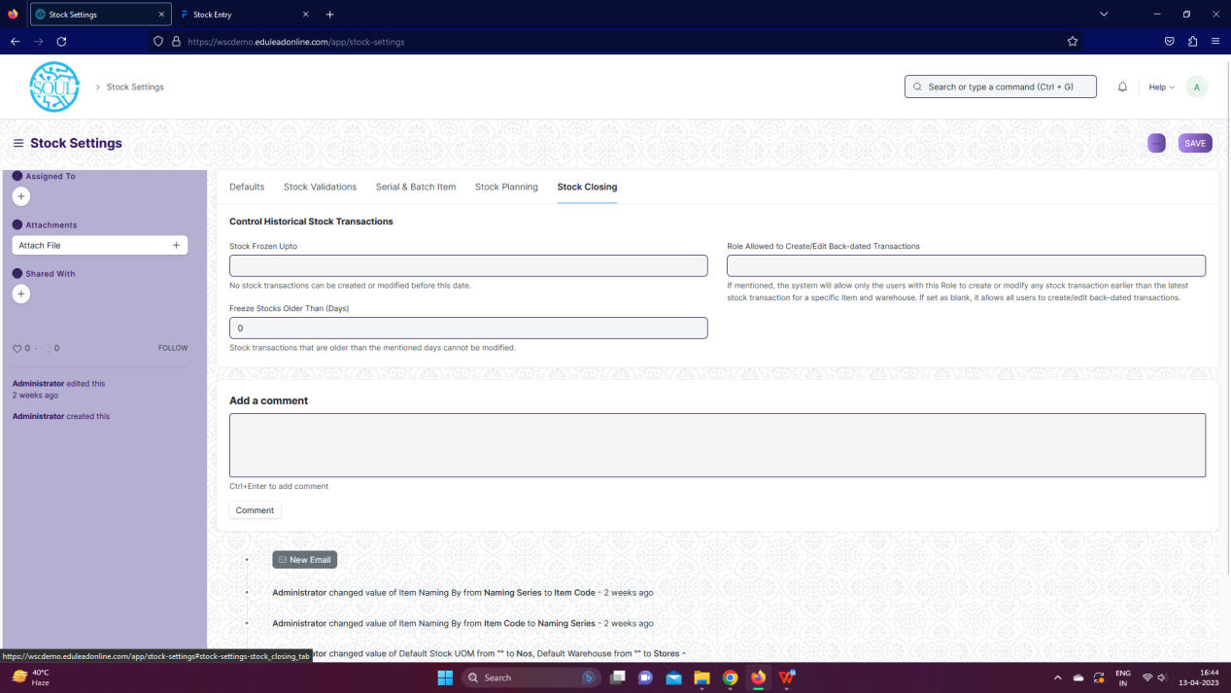**

Fig: Stock Setting Screen

**UI Fields**

The “Stock setting” screen shall consist of the following fields:

|  |  |  |  |  |  |
| --- | --- | --- | --- | --- | --- |
| **Field Label** | **Field Type** | Validation/ Action | Mandatory | **Remarks** | **R/N/D** |
| **Defaults (Tab Break)** | | | | | |
| Item Naming By | dropdown | Item Code /  Naming Series |  |  |  |
| Default Item Group | Link | Fetched from Item Group screen |  |  |  |
| Default Stock UOM | Link | Fetched from UOM screen |  |  |  |
| Default Warehouse | Link | Fetched from Warehouse screen |  |  |  |
| Sample Retention Warehouse | Link | Fetched from Warehouse screen |  |  |  |
| Default Valuation Method | dropdown | FIFO / Moving Average / LIFO |  |  |  |
| Auto Insert Item Price If Missing | Checkbox | User Input |  |  |  |
| Update Existing Price List Rate | Checkbox | User Input |  |  |  |
| **Stock Validations (Tab Break)** | | | | | |
| Over Delivery/Receipt Allowance (%) | Float | User Input |  |  |  |
| Over Transfer Allowance | Float | User Input |  |  |  |
| Role Allowed to Over Deliver/Receive | Link | Fetched from Role screen |  |  |  |
| Allow Negative Stock | Checkbox | User Input |  |  |  |
| Show Barcode Field in Stock Transactions | Checkbox | User Input |  |  |  |
| Convert Item Description to Clean HTML in Transactions | Checkbox | User Input |  |  |  |
| Action If Quality Inspection Is Not Submitted | dropdown | Stop / Warn |  |  |  |
| Action If Quality Inspection Is Rejected | dropdown | Stop / Warn |  |  |  |
| **Serial & Batch Item (Tab Break)** | | | | | |
| Automatically Set Serial Nos Based on FIFO | Checkbox | User Input |  |  |  |
| Set Qty in Transactions Based on Serial No Input | Checkbox | User Input |  |  |  |
| Disable Serial No And Batch dropdownor | Checkbox | User Input |  |  |  |
| Have Default Naming Series for Batch ID? | Checkbox | User Input |  |  |  |
| Naming Series Prefix | Text Input | User Input |  |  |  |
| **Stock Planning (Tab Break)** | | | | | |
| Raise Material Request When Stock Reaches Re-order Level | Checkbox | User Input |  |  |  |
| Notify by Email on Creation of Automatic Material Request | Checkbox | User Input |  |  |  |
| Allow Material Transfer from Delivery Note to Sales Invoice | Checkbox | User Input |  |  |  |
| Allow Material Transfer from Purchase Receipt to Purchase Invoice | Checkbox | User Input |  |  |  |
| **Stock Closing (Tab Break)** | | | | | |
| Stock Frozen Upto | Date | User Input |  |  |  |
| Freeze Stocks Older Than (Days) | Int | User Input |  |  |  |
| Role Allowed to Create/Edit Back-dated Transactions | Link | Fetched from Role screen |  |  |  |
| Role Allowed to Edit Frozen Stock | Link | Fetched from Role screen |  |  |  |

**Users: Roles and Permissions**

The following table describes the users and their roles and permissions for the screens :

|  |  |  |  |  |  |  |  |  |  |  |
| --- | --- | --- | --- | --- | --- | --- | --- | --- | --- | --- |
| **ID** | | **Role** | **Select** | **Read** | **Write** | **Create** | **Delete** | **Submit** | **Cancel** | **Amend** |
|  | GM-Procurement & Contract Management | Yes | Yes | Yes | Yes | Yes | Yes | Yes | Yes |
|  | Purchase Manager | Yes | Yes | Yes | Yes | Yes | Yes | Yes | Yes |